**________________________________________________________**

**Neo Revolution Online**

**Official Design Document**



**Done by:**

**142128G Ong Swee Seng**

**143803M Ong Xue Tian**

**143800H Adela Quek**

**142242U Nicodemus Kee**

**________________________________________________________**

**1.1 Game concepts**

Neo Revolution Online is a game that pits players fighting for their faction in a bid to win the war. Players manipulate their skills to clear each stage, located within cities, or even in various dungeons. From a third-person perspective and set in a futuristic layout, players combat in a beautiful environment and utilise mastery over their skills to gain dominance.

**1.2 Game Goals**

a) Provides players a skill-based game that chains combos to master

b) Maximum interactivity, using the environment for extra damage

c) Interactivity between large bosses(players can jump on the boss to attack it)

d) Customisability. players are not locked by what job they are like other RPGs such as maplestory, but rather, are limited by classes only.

This allows them to create their own unique skills set to suit their personality.

e) Appearance customisability. players can modify their appearance by purchasing clothing to wear over their armour. players also can export the template of their clothing to draw their own design over it, before re-importing it into the game.

**1.3 References**

a) Sword Art Online

b) Devil May Cry 3

c) Cabal Online

d) Final Fantasy VII

e) S4 League

f) Gundam Seed

g) Gundam Seed Destiny

h) Gundam 00

i) Gundam AGE

j) Assassin’s Creed

**1.4 Overview**

In the distant future, Earth has been over polluted due to deeds of mankind. Mankind was forced to migrate to a new planet, which they codenamed Neo Earth. Due to the atmosphere of the planet, humans were forced to find new ways to generate energy to power their otherwise extremely inefficient and unreliable systems. Eventually, technology that humans developed have allowed them to harness the raw energy within their bodies. The original concept was to allow humans to finally defeat the negative effects of friction by utilising raw energy to generate movable parts. The best part is that this energy is renewable, as the human body will constantly replenish energy by itself. However, this also gave rise to new forms of weapons. Blades no longer needed sharpening and guns no longer required physical ammo.

Eventually, people struggled for dominance, and it was discovered during several major wars each person had a different amount of raw energy, and that not everyone could harness the same amount of energy, unless they modified their physical bodies(generally a painful, horrifying experience.The after-effects of those who did such modifications were also generally scorned by the public for their appearance.). This eventually split the world into two, those under the Order, led by Godfrey, who wanted to harness the energy of everyone for greater good, and those under an entity known only as the Overlord, who led the faction known as Deception, which wanted people judged by their capabilities, and that those who were supreme should dominate those below.

In addition, the inhabitants of Neo Earth did not take the migration well. Constant attacks from them to both sides cause extra casualties, and they refuse to communicate with the humans, determined to chase the humans away from Neo Earth…

**Implementation**

Neo Revolution Online uses several methods to portray the story.

a) In-Depth Storyline + Cutscenes

Being the RPG game that it is, it has a lengthy and deep storyline, and is portrayed to the player through NPCs, cutscenes and background info. The more the player progresses, more secrets will be unveiled regarding the mysteries related to the storyline, such as the discovery of (harnessing human energy), the reasons behind the fighting as well as a more in-depth history behind the classes.

b) Background

Whichever side the player picks affects the environment that they start with. The layout of the environment is a constant reminder of where they are and how it is linked to the faction and behaviour of the characters. For example, Justicar City features a clean and simple layout, with the HQ in the center to represent it being the pillar of those that serve the Order, while Overlord City features a similar layout, but with subtle changes such as a statue of Overlord himself, implying that, while having their own beliefs, those under Overlord that serve the Deception still have a certain amount of order, and that the ‘good’ and ‘evil’ sides of the story are merely dependant on what the players’ mindset is.

c) Flashy Gameplay

The skills of the player are flashy and futuristic, reminding the player constantly of the fact that the setting is in the future, inconceivable by modern technology. Further enhancing this are gravity-defying areas and high speed acrobatic combat such as wall jumps.

d) Multiple storylines

Depending on the player’s choices at critical points of the storyline, the player has the potential to change the storyline. There are five endings:

- Players pick Justicar City and bring the Order to victory in the war, claiming Neo Earth

-Players pick Overlord City and bring the Deception to victory in the war, claiming Neo Earth

-Players defect from their faction and join the other side, bringing the side that they joined to victory

-Players defect from their faction and join the other side, but their actions only serve to lengthen the war, eventually bringing Neo Earth to a miserable state(bad ending)

-Both the Order and the Deception are forced to band together as the natives of Neo Earth have united to drive them out, and it becomes a power struggle for humans against the natives, with the humans eventually winning and claiming Neo Earth. Both sides then try to work out their differences for greater good.

**2 Game Flow**

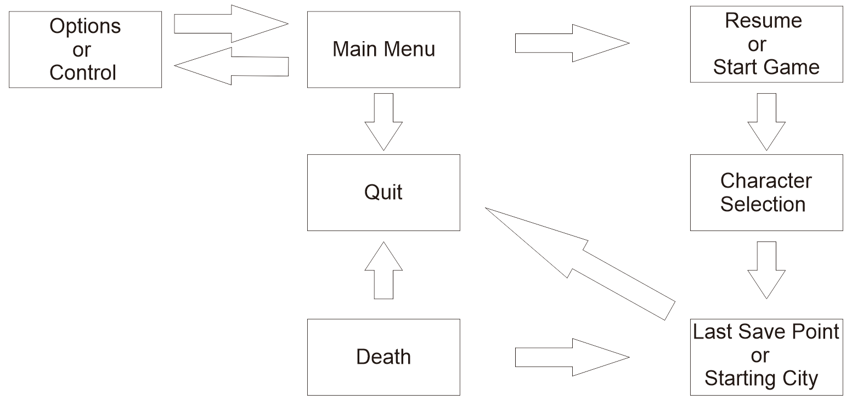

**2.1 Game Overview**

Upon going into the game, players are brought to the character selection screen, which displays the list of characters that they have created. After selecting the character, they will be brought into the game, where they last logged out, or if they are a new player, to the tutorial room.

In the game itself, towns are considered safe zones, and this is where players are able to interact with one another. Gateways at each town allow the player to teleport to where they wish to go to, be it another town, or a dungeon. Players are only allowed to teleport to towns(although story dungeons can be teleported). To discover new areas or go to dungeons, players need to travel to the location itself. During travelling, players will move alone, unless they are in a party, which then they would move with only their party members.

**2.2 Game Modes**

Story Mode

Players are tied to this mode most of the time. This is where players are able to complete storyline related quests to advance further, explore new locations, form parties to challenge dungeons, walk in the city to purchase equipments, relax and chat with one another, so on.

Dungeon Mode

When players enter a dungeon, they go solo, unless they are in a party, which then they would be in the dungeon with the party members. Here, only the dungeon itself is accessible. Dungeon difficulty is increased based on the number of players in the party. The dungeon itself features three modes: Explorer, Intermediate and Chaos mode. Explorer mode is the beginner mode, featuring basic drops and easy mobs. Intermediate features better drops but more challenging mobs. Chaos mode has the best drops, but also the hardest mobs. Puzzles for all three types of levels remain the same.

Travel Mode

This mode is used while players are travelling. Like dungeon mode, only party members can be seen, else players would be alone. There are random mob encounters as they travel, although several locations of the map are safe zones for the players to save, rest and recover. These safe zones also contain teleporters for them to return to previously discovered cities.

Arena Mode

Activated when players are in the arena. Players work together to survive endless waves of mobs until the end of the time limit. This is one of the co-op functions of the game, along with dungeon mode(when players are in a party) and travel mode(when players are in a party).

Duelling Mode

Activated when players select the Player VS Player option, group VS option or Free-for-all option in the arena. Players pit their skills against one another in the arena. In group VS, both parties will be entered into the arena to pit their skills in a team battle. In free for all, a bunch of players of similar level will be grouped into a single room, and the last one standing is the victor. Used to earn IGC and random loot(although boss-dropped loots will NOT be given) that may have a rare item.

Gambling Mode

Activated when players select a game of their choice in the gambling house. This is used to earn more IGC through gambling. Types of games vary, but all are luck-based, such as slot machines.

Trading room

A menu that is opened when players enter the trading room in the HQ and talk to the NPC there. Players are able to purchase items sold by other players or sell their own items here. This is another way to gain rare equipments while selling equips that have plenty of value but do not have any use to the player(e.g. rare equipments that are not related to the player’s class).

**2.3 Multiplayer in-depth + Side games**

Neo Revolution Online features several forms of alternate gameplay apart from the main storyline.

**Multiplayer functions for travelling and dungeons**

If players form a party with other players, they are able to explore Neo Earth with the party through travelling, and also can explore dungeons with the party. By working alongside other players, it gives the player a sense of camaraderie as well as preventing them from getting bored quickly. To offset this, dungeons explored in a party have a higher difficulty, but also provide equal rewards to everyone in the party.

**PVP(Player VS Player) Arena**

Players can also access the arena in cities for the purpose of battling other players to test their skills against one another. There are two modes:

PVP mode is a one vs one duel that pits players against one another in a battle for dominance, best out of three wins the match.

Group VS mode pits two parties of overall similar skill against one another in a battle for dominance. Group VS has the option of selecting best out of three or best out of ten. In the event of both teams being unable to decide, the computer will randomly select the option for them.

Free-for-all mode features gladiator-style combat where players are dumped into one arena and defeat one another until only one is left standing. Players can select either ten players or twenty players. Parties are also able to join the same room together, but will also kill one another once inside the arena.

**Survival Arena**

A co-op arena where players are thrown together and are required to work together to survive an endless wave of mobs until the timer expires. Parties that go in together will join the same arena.

**Gambling House**

A side game within Neo Revolution online is the ability to gamble to earn IGC. Players are able to play with slot machines, the roulette and Texas hold em’ poker, which rely on luck to win.

**2.4 Overview**

Neo Revolution Online focuses on a combination of dungeon-based puzzle games and 3D RPG fast-paced combat. Player skill is key in succeeding, and there is much emphasis placed on skill combos and character movement. The game mechanics also forces the player to improve their skills as the levels progress. For example, chaining skills together eliminates the delay between skills, allowing the player to quickly dish out more damage with lesser risk to their character.

The gameplay itself focuses on the player’s understanding of their own capabilities. Boss battle are not easy if they were to tackle to boss head-on. However, by utilising the environment, the difficulty level of the boss drops dramatically as the boss will be severely affected by the objects hurled at it, be it in damage or interfering with its combat capabilities. To aid in this, players control their character from a third-person perspective.

Finally, the game also focuses on customising the character to suit the player’s style. Skills are not locked by their specialisation, but rather by their class to allow the player more diversity in their skills(more on this later). Armour can also be mixed and matched(refer to armour section). Aesthetic traits such as weapon and armour skins allow player to decorate their character to the looks they want their character to portray, as Neo Revolution Online is played in third-person, and therefore allows the player to view their character at all times..

**3 Classes**

**3.1 Swordsman**

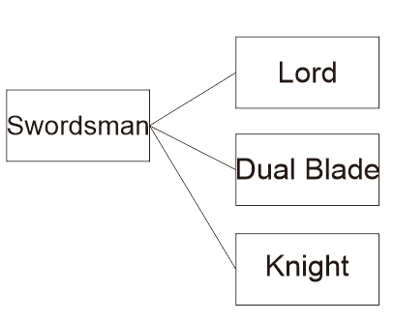

a)The **Swordsman** is one out of seven classes that new players can choose from , this class places emphasis on the usage of sword.Players using this class can choose from equipping 1-Handed Sword with or without shield and Great Sword.

It utilises efficient high combo attacks no matter what weapon is equipped, and is an all-rounder, its true strength dependent on what the players have chosen.

b)At Level 20 players using the Swordsman class are able to class advance to either Lord , Dual Blade or Knight.

c)The **Lord** is a class which specialise in ‘tanking’ which means able to take a lot of damage for a certain amount of time without healing.Equipped with 1-Handed Sword and Shield , players can choose to equip it with with either light or heavy armor to suit their own combat needs , players are also able to access tons of healing / defensive skills which are beneficial to the Lord.

Players that choose not to equip the Shield are able to have lesser animation time of their skills(due to the sword swinging faster, unhampered by the weight of the shield), but their healing and defensive skills are weaker without the shield equipped.

d)**Dual Blade,**the dual blade class double the DPS(Damage Per Second) of a player but at the cost of little parry.Able to equipped 2 1-Handed the dual blade class is powerful depending on how players are able to control it , knowing when to dodge or attack is important as this class have little defense capability.

e)**Knight ,** the knight is a class that specializes in the usage of the Great Sword. The knight is able to have a high DPS and also able to block at the same time but the downside is that the great sword is a slow weapon so players using the Knight class have to be careful and time their move.

**3.2** **Gunner**

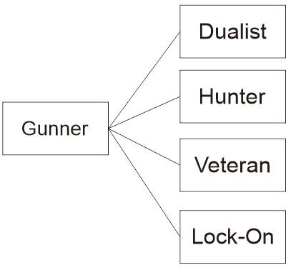

a)The **Gunner** is the second out of seven classes that new players can choose from to play. This class specialize in the usage of guns. Players playing this class are able to choose from Pistol , Assault Rifle , Shotgun and Sniper.

Having the highest DPS from all the classes, it uses quick and/or hard hitting attacks to decimate opponents. However, they suffer from weak armour, and apart from the Dualist, suffer from somewhat slower movement speed for a class with light armour.

b)At level 20 , players using Gunner are able to class advance to either Dualist , Hunter , Veteran or Lock-On

c)The **Dualist** is the same as the dual blade being able to dual wield pistol , able to fire twice the amount of bullets and able to reload the bullets at half the time but , disadvantage is that the DPS for this class is low(compared to other gunner classes).

d)The **Hunter** is a class that specialize in the usage of Assault Rifle. This class is able to have a high DPS and fast reload speed but however the recoil and high fire rate of this weapon tend to cause players to miss.

e)**Veteran ,** the veteran is a class that specialize in the use of Shotgun. Able to have a high fire rate depending on the model used and high DPS, this class suffers from low reload speed and is only effective at close range, as the damage done by a shotgun weakens over range.

f)**Lock-On ,** Lock-On is a class that specializes in the usage of sniper.

This class is able to ensure a more accurate placement of bullets over a long distance, however, it suffers from low DPS and from the fact that it have a low fire rate and is only able to shoot 1 bullet at a time. It is offset by having a high damage output at any range. It is also the only gunner class with piercing capabilities.

**3.3 Assassin**

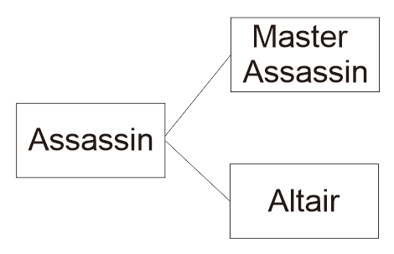

a)The **Assassin** is the third out of seven class that players can choose from. This class emphasis on stealth movement, quick kills and status effects. Players using this class are only able to use dagger.

It is capable of moving quickly, with short and deadly skills, and many DoT(Damage over Time) skills. However, they have the poorest armour of all classes, with little to no defensive skills.

b)At level 15 , players using Assassin may class advance to either Altair or Master Assassin

c)**Altair** are equipped with the 1-Handed curved blade to upgrade to katana which is only unlocked when players have train the curved blade skill sufficiently.

This class is able to have a high DPS and stealth for lower chance of detection but it have a longer recharge time for its skills as compared to other characters.

d)The **Master Assassin** is a class thatuses hidden blade along with dagger from its previous class Assassin.This class also have stealth and able to land more critical hits however it suffers from the fact that it have a low range attacking area.

**3.4 Archer**

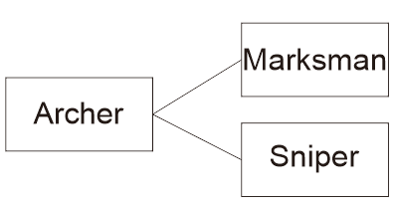

a)The **Archer** is the fourth out of seven class that new players can choose from.This class emphasis on long range stealth skill,players using this class are able to equip either bow or crossbow.

**Archers** feature long range attacks that do similar damage than gunners, but have piercing abilities better than the Lock-On. They are also quicker than gunners, but lack many aoe skills.

b)At level 15 , players using the archer class are able to class advance to either Marksman or Sniper

c)The **Marksman** is a class that specializes in the usage bows. Players using the marksman class suffer from having weaker DPS (Damage per Shot) as compared to Crossbow but they will have a high fire rate.

d)The **Sniper** is a class that specializes in the usage of Crossbow.

Players using the Sniper class are able to have stronger DPS(Damage per shot) but however they will suffer from a low fire rate.

**3.5 Berserker**

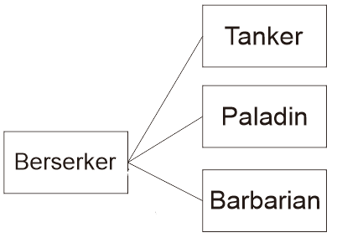

a)The **Berserker** class is the fifth out of seven class that new players can choose from. Players using the Berserker class are able to equip heavy weapons such as Dual Shield, Lance, Axe and Mace.

This class features a combination of having high attack, defense or a combination of both. However, they are harder to control, and lack healing skills. Overall, they also have lesser speed than other classes

b)At level 20, players using the Berserker class are able to class advance to either Tanker, Paladin, Barbarian and Page.

c)The **Tanker** is a class that specializes in the usage of Dual Shield.

Players using this class will have high attack and defense capabilities but it suffers from its slow speed.

d)The **Paladin** is a class that specializes in the usage of lance.Players can choose to equip only Lance or Lance with Shield. Players using this class are able to equip only Lance or Lance and Shield. Paladin using Lance only are able to have a wider range of attack but at the same time having lower defense whereas Paladin using Lance and Shield are only able to have a lower range of attack but with higher defense.

e)The **Barbarian** is a class that specializes in the usage of Axe.Players using this class are able to choose between equipping one-handed axe only, one-handed axe with shield or Dual Axe(after player have level up the skill Dual Wield high enough).All 3 equipment type of the barbarian class have high DPS and fast swing however for one-handed axe player they will suffer from lower defense, whereas for Barbarian that uses one-handed axe with shield is have a higher defense as compared to one-handed axe but it suffers at its attack speed.Last but not least for the barbarian that choose to use Dual Wield,it will definitely have a higher attack speed and DPS but however it will have the least defense as compared to Barbarian that uses one-handed axe and one-handed axe with shield.

**3.6 Skirmisher**

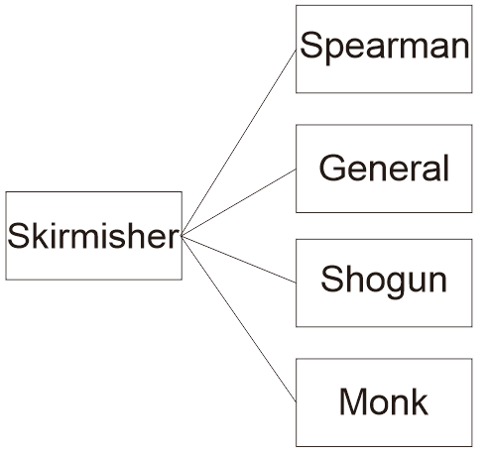

a)The **Skirmisher** is the sixth out of seven classes that new players can choose from.

This class specializes in the usage of long pole weapons such as Spear,Polearms,Glaives and Staff, it is capable of dealing high DPS but they also have the lowest attack speed as compared to other class

Skirmishers favour wide and long attack ranges, with decent defenses keeping them alive. They feature many large area-of-effect skills. However, they suffer from slow attack speed, making it a tactical class dependant on player skill.

b)At level 20,players using the Skirmisher class are able to class advance to either Spearman,General,Shogun or Monk.

c)The **Spearman** is a class that specializes in the usage of Spear.Players using this class are able to have a high DPS and piercing but however they have a slow attack speed so players have to be careful while using Spearman.

d)The **General** is a class that specializes in the usage of Polearms.General have a high DPS and attack range but however this class will suffer from its slow attack speed same as the Spearman.

e)The **Shogun** is a class that specializes in the usage of Glaive. The Shogun have a high attack range but this class suffer due to its low attack.

f)The **Monk** is a class that specializes in the usage of Staff weapons. Monk will have a high DPS, attack speed and healing skills, but however the Monk will have the lowest HP as compared to other class.

**3.7 Radical**

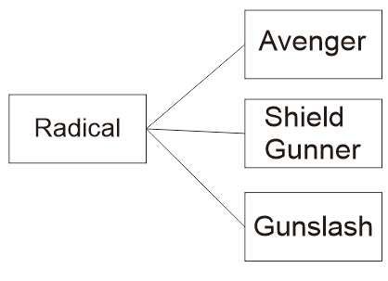

a)The **Radical** class is the Seventh class that new players can choose from. Players using this class are able to choose unique weapons such as Shield only,Gun and sword and Gun with Shield.

Radicals are like what their class says, radical. Radical classes often bring a certain aspect of the class to the highest possible, while leaving another aspect untouched as a downside.

b)At Level 20, Players using the Radical class are able to class advance to either Avenger,Shield Gunner or Gunslash.

c)The **Avenger** is a class that specializes in the usage of Shield.Players using the Avenger class will have high defense and attack range but however they will also have the least energy as compared to other classes.

d)The **Shield Gunner** is a class that specializes in the usage of Gun and Shield.Players using the Shield Gunner are able to equip the jetpack booster which provides that a high mobility and high DPS however they can only use the jetpack booster for a set time limit until they have to wait for it to cool down.

e)The **Gunslash** is a class that specializes in the usage of Gun and Sword. Players using this class are able to have a high DPS and attack speed but however they will have lesser defense capabilities as compared to other class.

**3.8 Class Skills**

**Explanations for skills**

Unlike RPG games, Neo Revolution online does not have a skill tree. Instead, players are given a set of skills for them to select from. Upon reaching the requirements for the next level(e.g. Beginner to Advance), they are given all skills from the next set, but are required to select a specialised class. They are free to select any skill from Advance and Expert level, but for skills in the master level, they will only have the skills in their specialised class. This allows them to develop a skill set that suits their playing style.

**Individual skills**

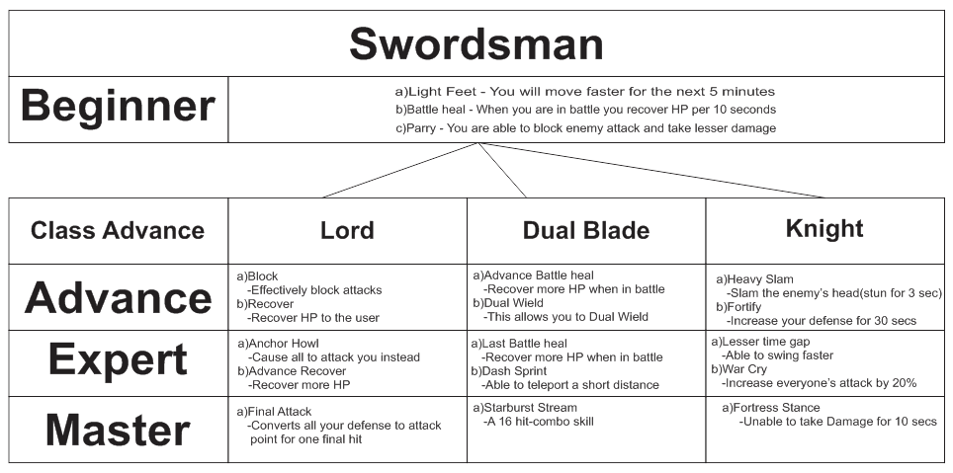

**Beginner:** a)Light Feet - You will move faster for the next 5 minutes

b)Battle heal - When you are in battle you recover HP per 10 seconds

c)Parry - You are able to block enemy attack and take lesser damage

**Advance: 1)Lord** a)Block - Effectively block attacks

b)Recover - Recover HP to the user

**2)Dual Blade** a)Advance Battle heal - Recover more HP when in battle

b)Dual Wield - This allows you to Dual Wield

**3)Knight** a)Heavy Slam - Slam the enemy’s head(stun for 3 sec)

b)Fortify - Increase your defense for 30 secs

**Expert: 1)Lord** a)Anchor Howl - Cause all to attack you instead

b)Advance Recover - Recover more HP

**2)Dual Blade** a)Last Battle heal - Recover more HP when in battle

b)Dash Sprint - Able to teleport a short distance

**3)Knight** a)Lesser time gap - Able to swing faster

b)War Cry - Increase everyone’s attack by 20%

**Master: 1)Lord** a)Final Attack - Converts all your defense to attack point for one final hit

**2)Dual Blade** a)Starburst Stream - A 16 hit-combo skill

**3)Knight** a)Fortress Stance - Unable to take Damage for 10 secs

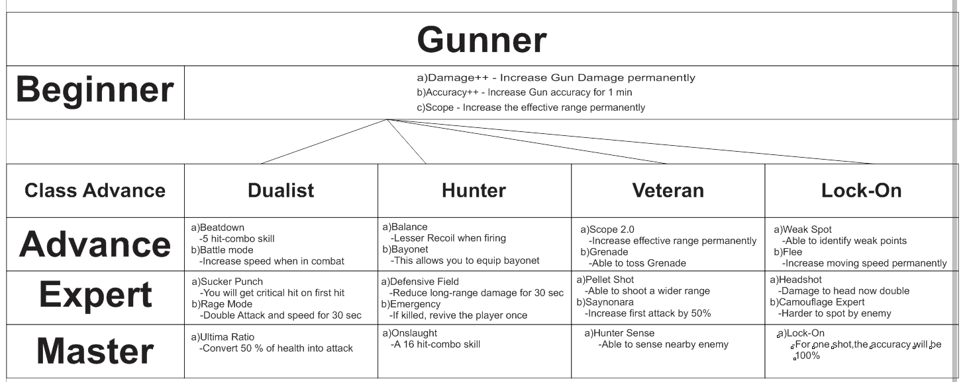

**Beginner:** a)Damage++ - Increase Gun Damage permanently

b)Accuracy++ - Increase Gun accuracy for 1 min

c)Scope - Increase the effective range permanently

**Advance: 1)Dualist** a)Beatdown - 5 hit-combo skill

b)Battle mode - Increase speed when in combat

**2)Hunter** a)Balance - Lesser Recoil when firing

b)Bayonet -This allows you to equip bayonet

**3)Veteran** a)Scope 2.0 - Increase effective range permanently

b)Grenade - Able to toss Grenade

**4)Lock-On** a)Weak Spot - Able to identify weak points

b)Flee - Increase moving speed permanently

**Expert: 1)Dualist** a)Sucker Punch - You will get critical hit on first hit

b)Rage Mode - Double Attack and speed for 30 sec

**2)Hunter** a)Defensive Field - Reduce long-range damage for 30 sec

b)Emergency - If killed, revive the player once

**3)Veteran** a)Pellet Shot - Able to shoot a wider range

b)Saynonara - Increase first attack by 50%

**4)Lock-On** a)Headshot - Damage to head now double

b)Camouflage Expert - Harder to spot by enemy

**Master: 1)Dualist** a)Ultima Ratio - Convert 50 % of health into attack

**2)Hunter** a)Onslaught - A 16 hit-combo skill

**3)Veteran** a)Hunter Sense - Able to sense nearby enemy

**4)Lock-On** a)Lock-On - For one shot,the accuracy will be 100%

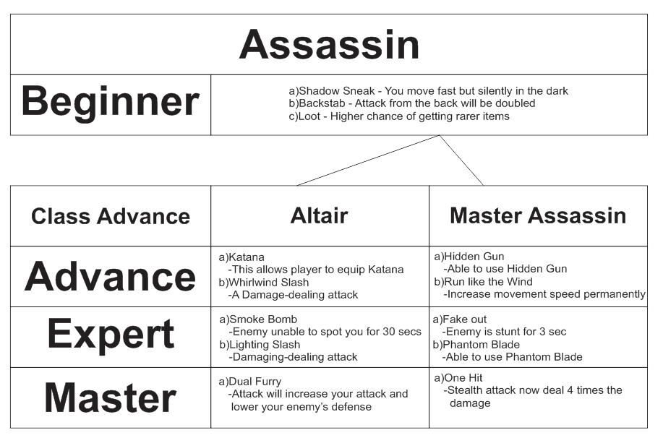

**Beginner:** a)Shadow Sneak - You move fast but silently in the dark

b)Backstab - Attack from the back will be doubled

c)Loot - Higher chance of getting rarer items

**Advance:** **1)Altair** a)Katana -This allows player to equip Katana

b)Whirlwind Slash - A Damage-dealing attack

**2)Master Assassin** a)Hidden Gun - Able to use Hidden Gun

b)Run like the Wind - Increase movement speed permanently

**Expert: 1)Altair** a)Smoke Bomb - Enemy unable to spot you for 30 secs

b)Lighting Slash - Damaging-dealing attack

**2)Master Assassin** a)Fake out- Enemy is stunt for 3 sec

b)Phantom Blade - Able to use Phantom Blade

**Master: 1)Altair** a)Dual Furry- Attack will increase your attack and lower your enemy’s defense

**2)Master Assassin** a)One Hit - Stealth attack now deal 4 times the damage

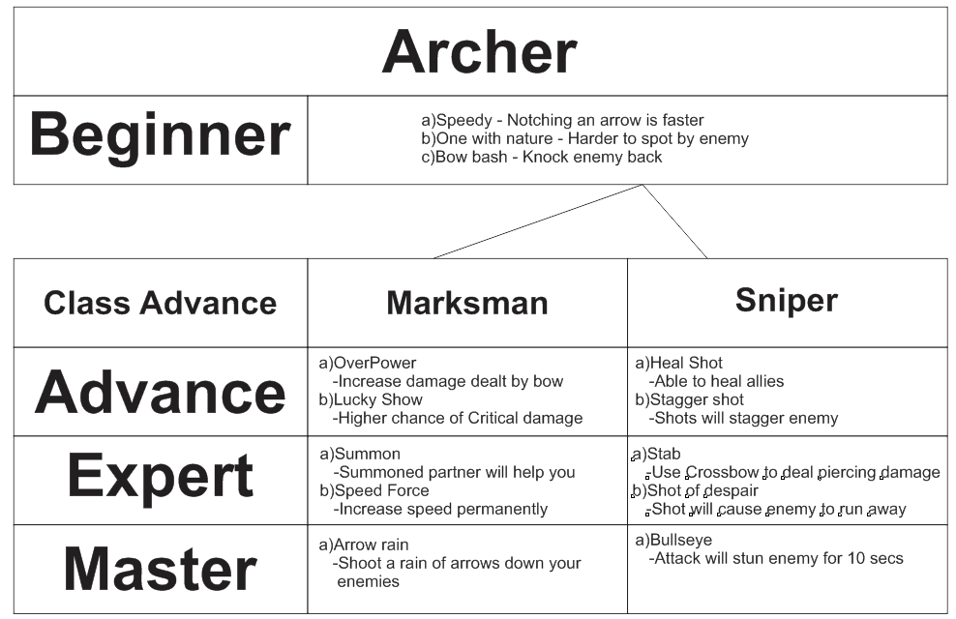

**Beginner:** a)Speedy - Notching an arrow is faster

b)One with nature - Harder to spot by enemy

c)Bow bash - Knock enemy back

**Advance: 1)Marksman** a)OverPower - Increase damage dealt by bow

b)Lucky Show - Higher chance of Critical damage

**2)Sniper** a)Heal Shot - Able to heal allies

b)Stagger shot - Shots will stagger enemy

**Expert: 1)Marksman** a)Summon - Summoned partner will help you

b)Speed Force - Increase speed permanently

**2)Sniper** a)Stab - Use Crossbow to deal piercing damage

b)Shot of despair - Shot will cause enemy to run away

**Master: 1)Marksman** a)Arrow rain - Shoot a rain of arrows down your enemies

**2)Sniper** a)Bullseye - Attack will stun enemy for 10 secs

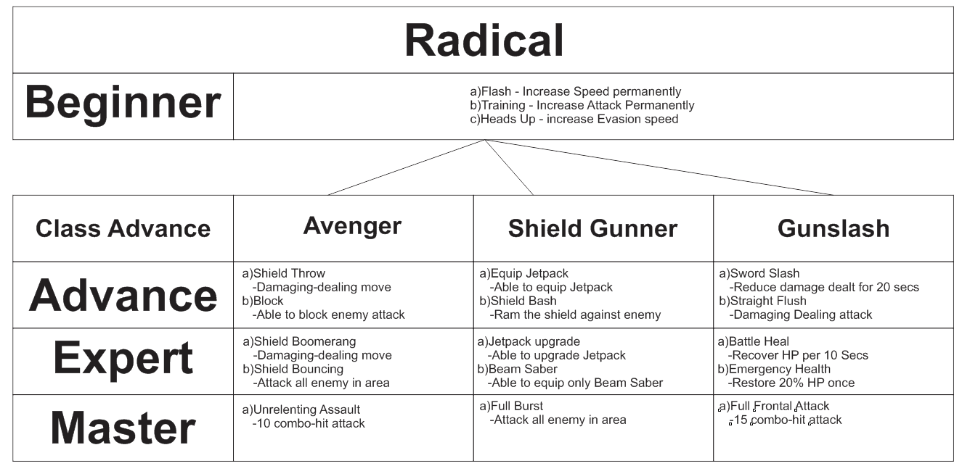

**Beginner:** a)Flash - Increase Speed permanently

b)Training - Increase Attack Permanently

c)Heads Up - increase Evasion speed

**Advance: 1)Avenger** a)Shield Throw - Damaging-dealing move

b)Block - Able to block enemy attack

**2)Shield Gunner** a)Equip Jetpack - Able to equip Jetpack

b)Shield Bash - Ram the shield against enemy

**3)Gunslash** a)Sword Slash - Reduce damage dealt for 20 secs

b)Straight Flush - Damaging Dealing attack

**Expert: 1)Avenger** a)Shield Boomerang - Damaging-dealing move

b)Shield Bouncing - Attack all enemy in area

**2)Shield Gunner** a)Jetpack upgrade - Able to upgrade Jetpack

b)Beam Saber - Able to equip only Beam Saber

**3)Gunslash** a)Battle Heal - Recover HP per 10 Secs

b)Emergency Health - Restore 20% HP once

**Master: 1)Avenger** a)Unrelenting Assault - 10 combo-hit attack

**2)Shield Gunner** a)Full Burst - Attack all enemy in area

**3)Gunslash** a)Full Frontal Attack - 15 combo-hit attack

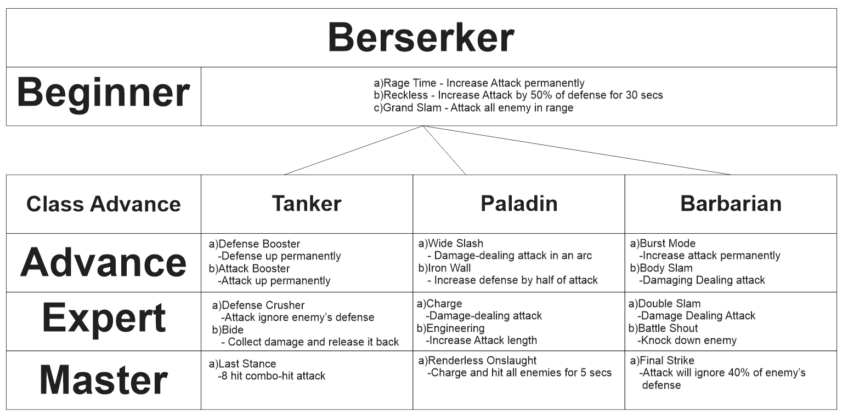

**Beginner:** a)Rage Time - Increase Attack permanently

b)Reckless - Increase Attack by 50% of defense for 30 secs

c)Grand Slam - Attack all enemy in range

**Advance: 1)Tanker** a)Defense Booster - Defense up permanently

b)Attack Booster - Attack up permanently

**2)Paladin** a)Wide Slash - Damage-dealing attack in an arc

b)Iron Wall - Increase defense by half of attack

**3)Barbarian** a)Burst Mode - Increase attack permanently

b)Body Slam - Damaging Dealing attack

**Expert: 1)Tanker** a)Defense Crusher - Attack ignore enemy’s defense

b)Bide - Collect damage and release it back

**2)Paladin** a)Defense Crusher - Attack ignore enemy’s defense

b)Bide - Collect damage and release it back

**3)Barbarian** a)Double Slam - Damage Dealing Attack

b)Battle Shout - Knock down enemy

**Master: 1)Tanker** a)Last Stance - 8 hit combo-hit attack

**2)Paladin** a)Renderless Onslaught - Charge and hit all enemies for 5 secs

**3)Barbarian** a)Final Strike- Attack will ignore 40% of enemy’s defense

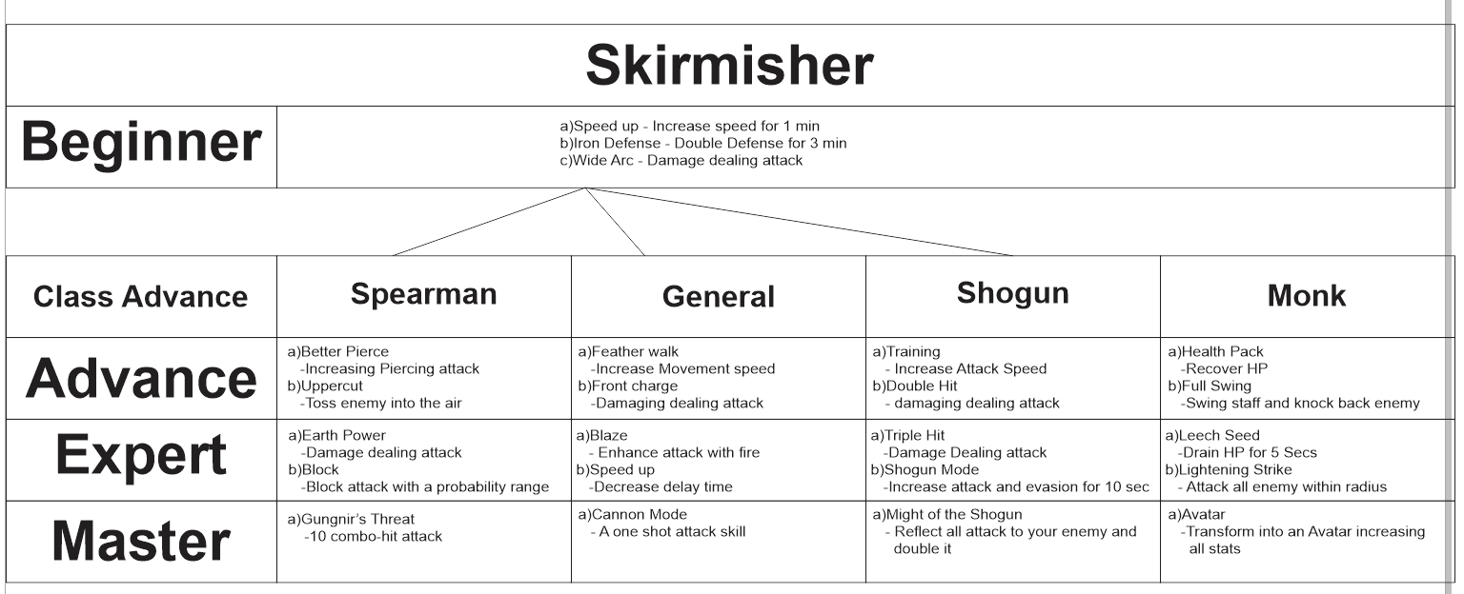

**Beginner:** a)Speed up - Increase speed for 1 min

b)Iron Defense - Double Defense for 3 min

c)Wide Arc - Damage dealing attack

**Advance: 1)Spearman** a)Better Pierce - Increasing Piercing attack

b)Uppercut - Toss enemy into the air

**2)General** a)Feather walk - Increase Movement speed

b)Front charge - Damaging dealing attack

**3)Shogun** a)Training - Increase Attack Speed

b)Double Hit - damaging dealing attack

**4)Monk** a)Health Pack - Recover HP

b)Full Swing - Swing staff and knock back enemy

**Expert: 1)Spearman** a)Earth Power - Damage dealing attack

b)Block - Block attack with a probability range

**2)General** a)Blaze - Enhance attack with fire

b)Speed up - Decrease delay time

**3)Shogun** a)Triple Hit - Damage Dealing attack

b)Shogun Mode - Increase attack and evasion for 10 sec

**4)Monk** a)Leech Seed - Drain HP for 5 Secs

b)Lightening Strike - Attack all enemy within radius

**Master: 1)Spearman** a)Gungnir’s Threat -10 combo-hit attack

**2)General** a)Cannon Mode - A one shot attack skill

**3)Shogun** a)Might of the Shogun - Reflect all attack to your enemy and double

**4)Monk** a)Avatar -Transform into an Avatar increasing all stats

**4 The World Layout**

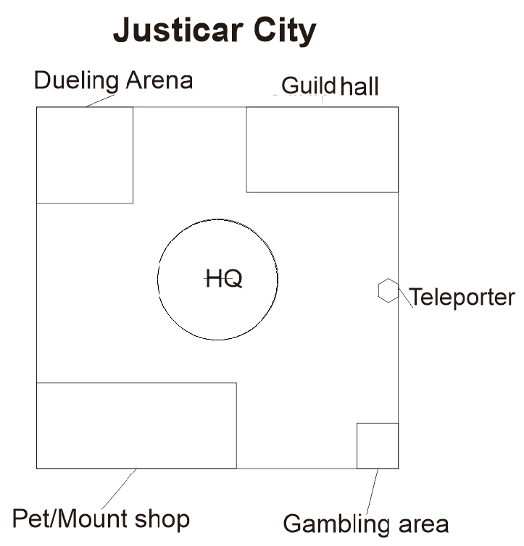

For players selecting the Order as their faction, they will be first spawned into Justicar city. It has a simple layout, with the HQ in the center to represent that it is the main building of the city. The duelling arena and gambling area are located across each other, far apart from one another, to represent the differences between honorable duelling, and luck-based gambling. The guild hall is located nearer to the arena than the gambling arena to further distinguish the difference in status. Finally, the pet/mount shop occupies a large area at the lower left of the city to show that pets/mounts require a lot of care and space to upkeep. A teleporter serves as a gateway between the city and the outside world, and is used to emphasise the futuristic theme.

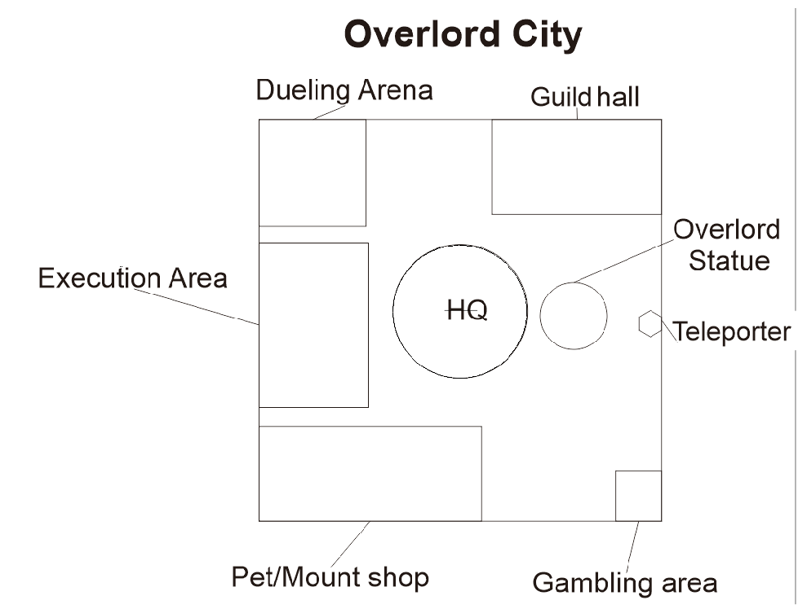

Overlord City is the spawn point of those that select the faction, Deception. It doesn’t differ much from Justicar City to show that it still has its own form of order, and that they are merely more extreme in their methods. To represent this, it has a statue of Overlord himself(herself?) directly in front of the HQ as a display of power. It also has an execution area, which is purely aesthetic but serves to represent that those that do not obey the will of Overlord will be executed without trial for the sake of the beliefs of those under Overlord.

**4.1 Tutorial One - Introduction**

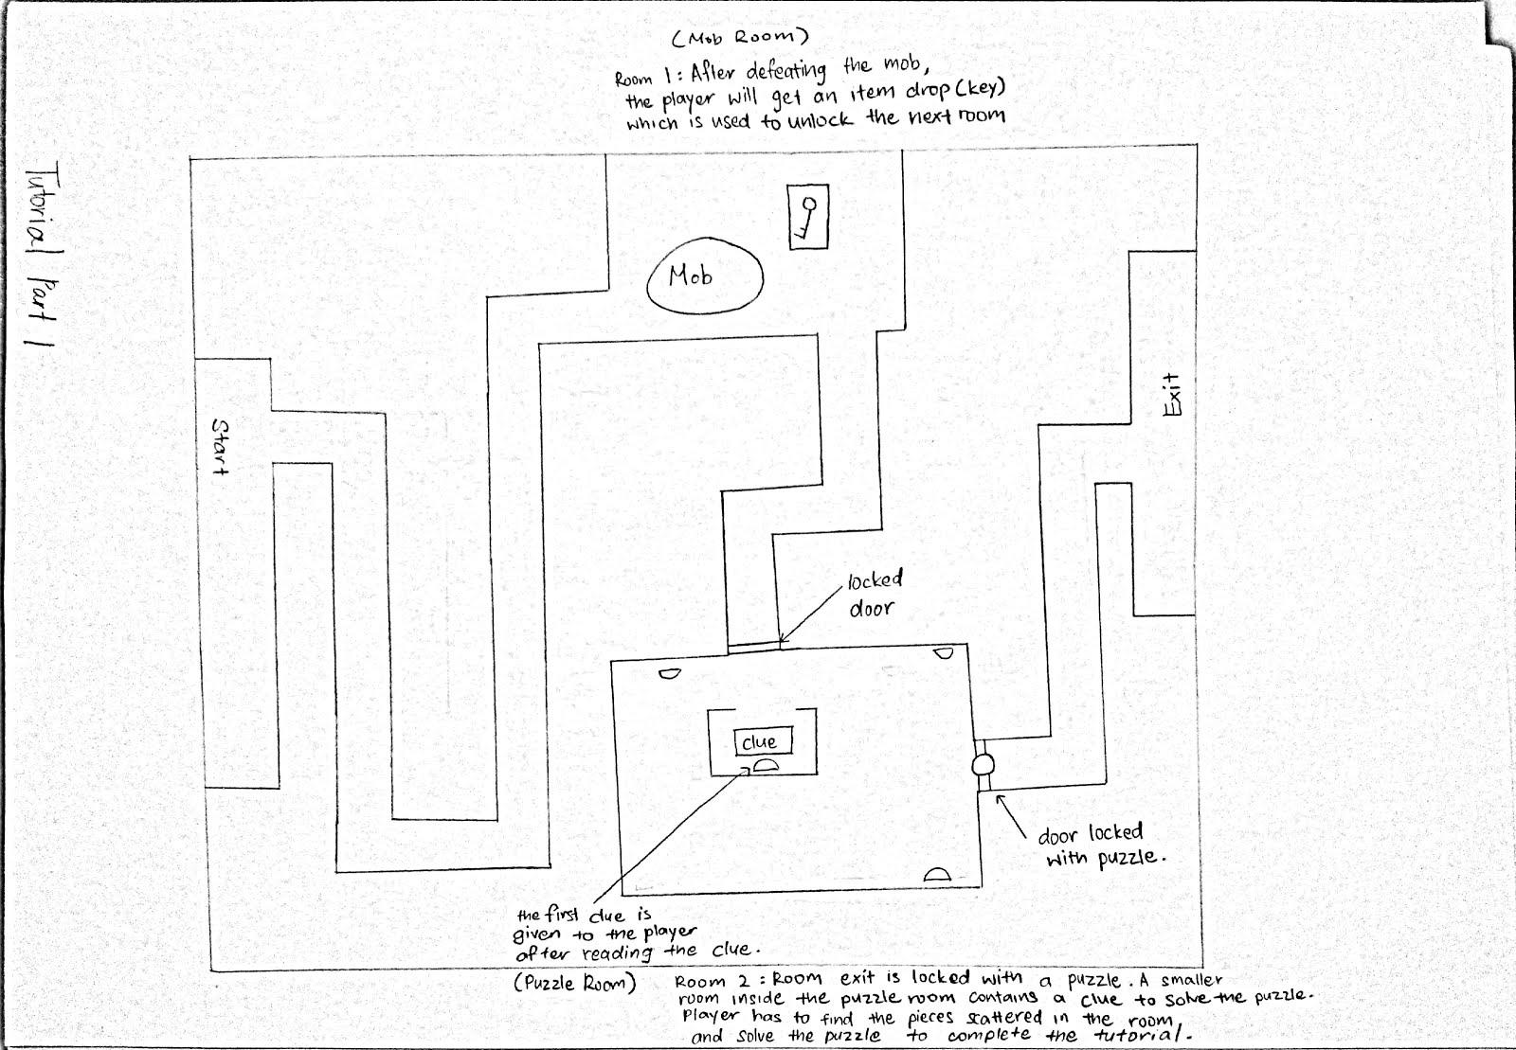

A small dungeon generated by the HQ, used to coach new players on controls and introduce them to puzzles in the game.

Objects:

- Key(for unlocking door)

-Clue: serves as a hint for the player to unlock the second door

-Locked Door: one of the keys is used to unlock it

-Door locked with puzzle: the second door unlocked by solving the puzzles

-Puzzle pieces: used to unlock the second door

Step-by-step walkthrough:

Objective: Reach the end

-announcer-Welcome to Neo Revolution Online. This tutorial is will cover gameplay basics to enable you to better understand the game.

Objective: Walk forward to the point. (Command shown on screen)

-players use the forward function-

Objective: Walk left to the point (Command shown on screen)

-players use the left function-

Objective: Walk right to the point (Command shown on screen)

-players use the right function-

Objective: Walk backwards to the point (Command shown on screen)

-announcer- Proceed onwards

-players walk a certain distance, before being ambushed by mobs-

-announcer- Opponents are a natural enemy in your scale of work. Eliminate them. (Attack key & kick function shown on screen)

Objective: Dispatch the enemies

-players use attack key to dispatch enemies-

-announcer- Skills make your combat flashy, and easier. Try them. (A skill key is highlighted)

Objective: Dispatch the enemies with skills

-players use skill key to dispatch enemies-

-announcer- There appears to be a key over there. Pick it up with the pickup function (A skill key is highlighted).

Objective: Pick up the key(Command on screen)

-players pick up the key-

-announcer- proceed.

-players reach locked door-

-announcer- The key you previously picked up appears useful. try it.-

Objective: Unlock the door (Command on screen)

-players unlock door-

-players reached door locked with puzzle-

-announcer- It appears that this is locked not with a key, but with puzzle pieces. The room you are currently in appears to have a clue in the center. It might provide hints.

Objective: Solve the puzzle of the door

-players decipher the meaning behind the clue, locate the puzzle pieces-

-players solve the puzzle-

-players reach the end-

Tutorial Mission complete.

**4.2 Tutorial Two - Simple dungeon**

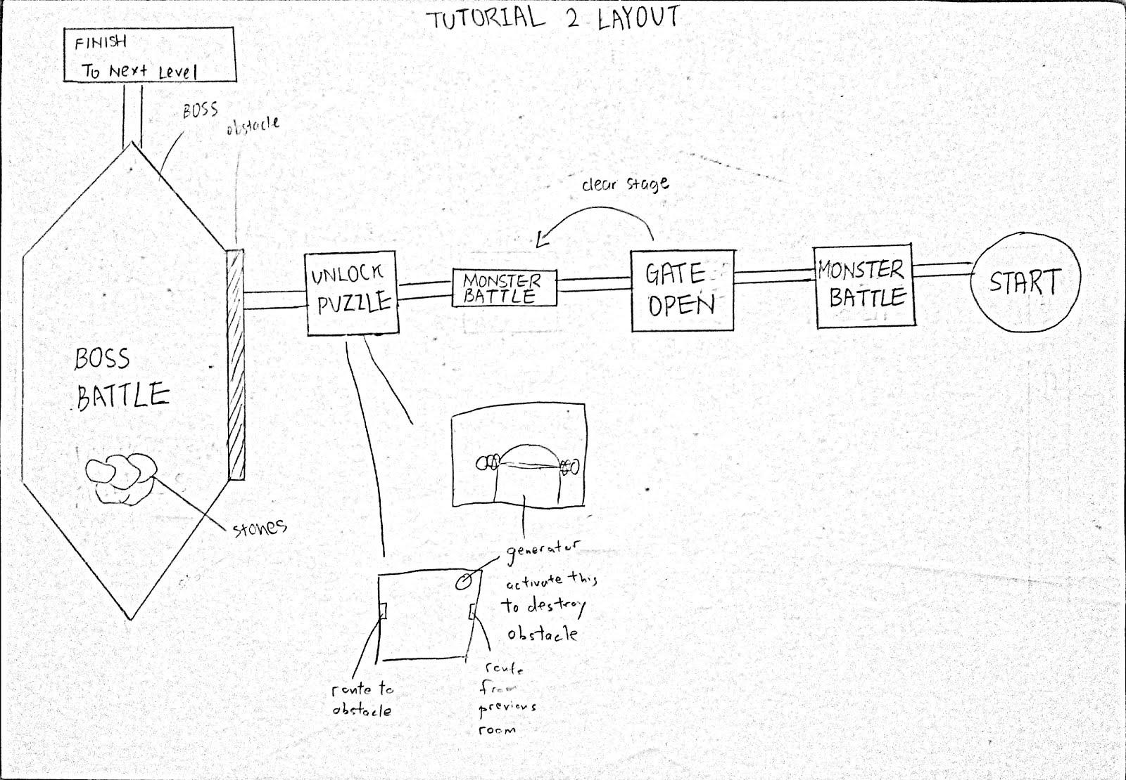

A simple straightforward dungeon generated, used to coach new players on obstacles and how environment affects combat.

Objects:

- Gates: As an entry to a narrower monster battle after a monster battle is cleared.

-Generator: As an activation to destroy obstacle.

-Sealed Door: Act as an obstacle

-Stones: Act as objects to help players with the boss battle.

-Breakable Pillar: Used as a trigger for stones to fall

Step-by-step walkthrough:

Objective: Get to the end of the dungeon.

-announcer- Welcome to tutorial 2.

Objective: Defeat the monsters

-announcer- The environment can be exploited to your advantage. Stones, walls, pillars, and such deal more damage to your opponents. A good trick is to use skills to knock your opponent to the walls. Another would be using your kicks on environment objects that are movable. Experiment with this.

-players defeat the monsters-

-gate is unlocked upon defeating first set of monsters, revealing more monsters in the next room-

-players defeat the monsters-

-players proceed to the sealed door-

-announcer- It appears that it is sealed.

Objective: Open the sealed door

-announcer- The previous room appears to have a generator to unlock the door. Activate it.

Objective: Activate the generator

-players activate the generator and the door opens, revealing the boss-

-announcer- This appears to be a boss. Charging it head on would be the height of folly. Try getting on its back.

Objective: Defeat the boss

Objective: Get on the back of the boss

-players jump on the back of the boss and do damage. After a while, the boss throws them off, severely injuring them.

-announcer- I see something to turn the tide of battle. There appears to be a destructible object to trigger a rockslide on the boss.

Objective: Locate an item to trigger a rockslide

-players destroy a crumbling pillar, which cause a rockslide to destroy the boss-

-players proceed to the end-

Tutorial Complete.

**4.3 Level One - HQ assault**

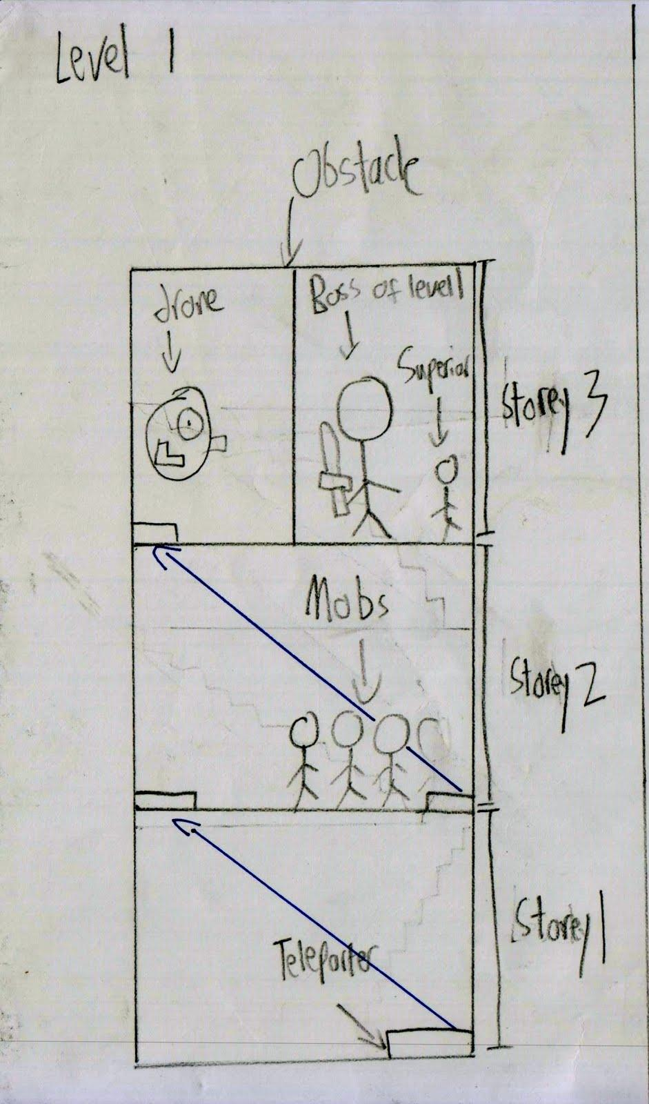

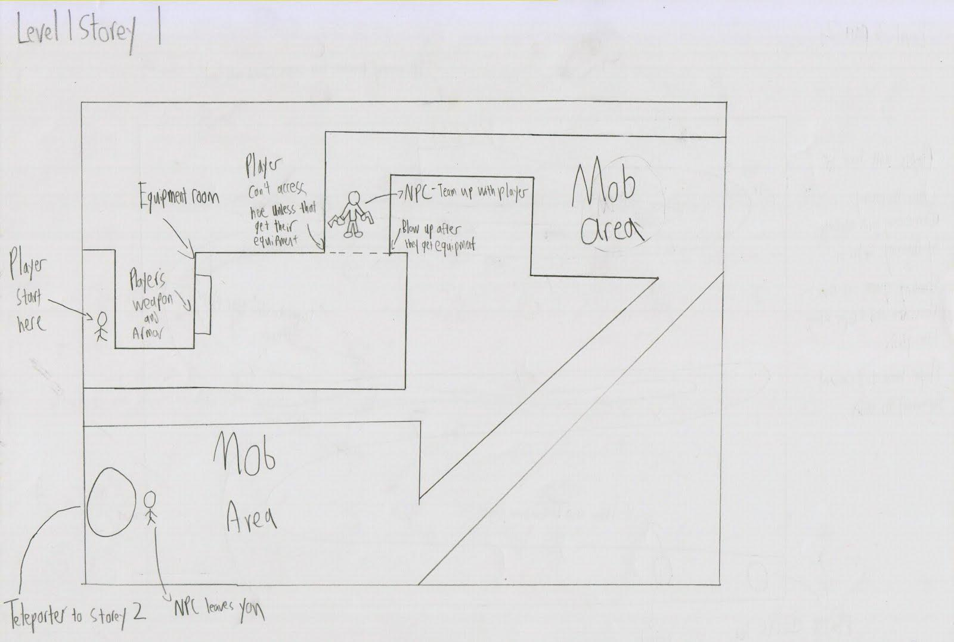

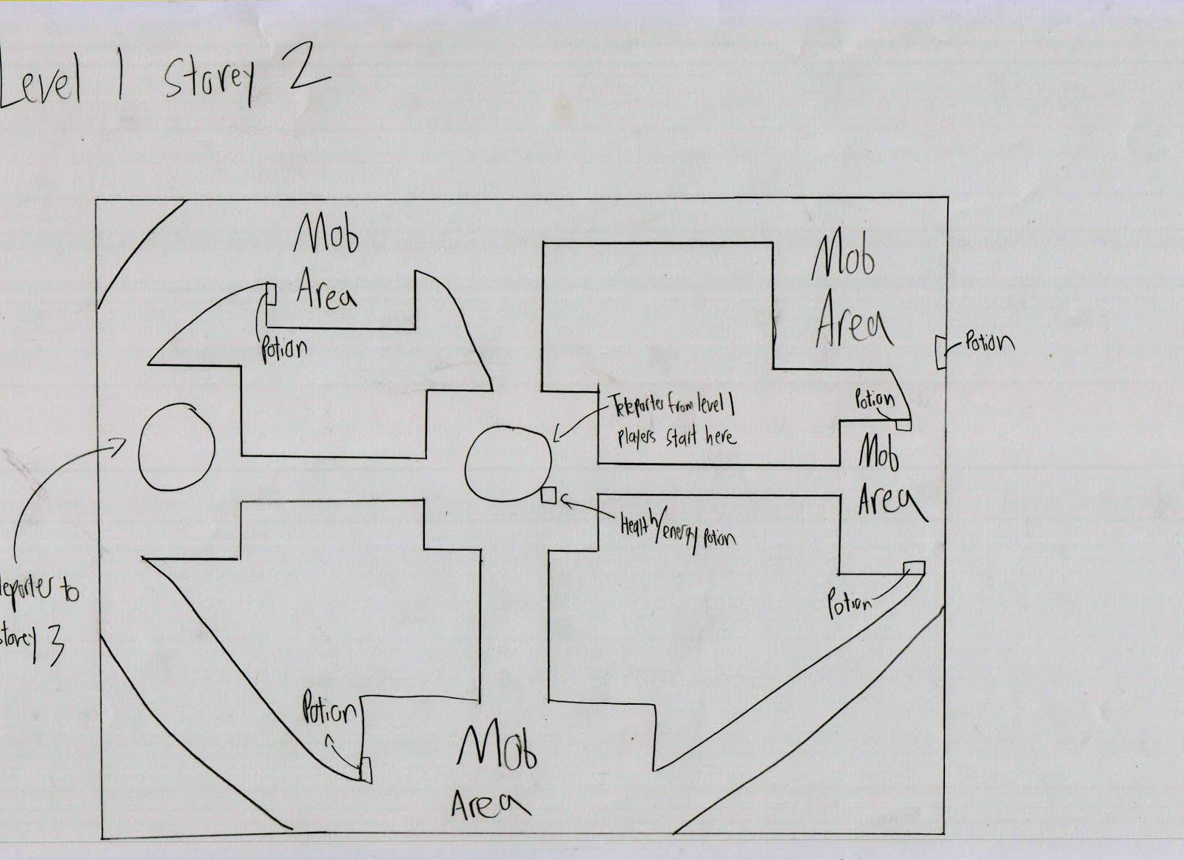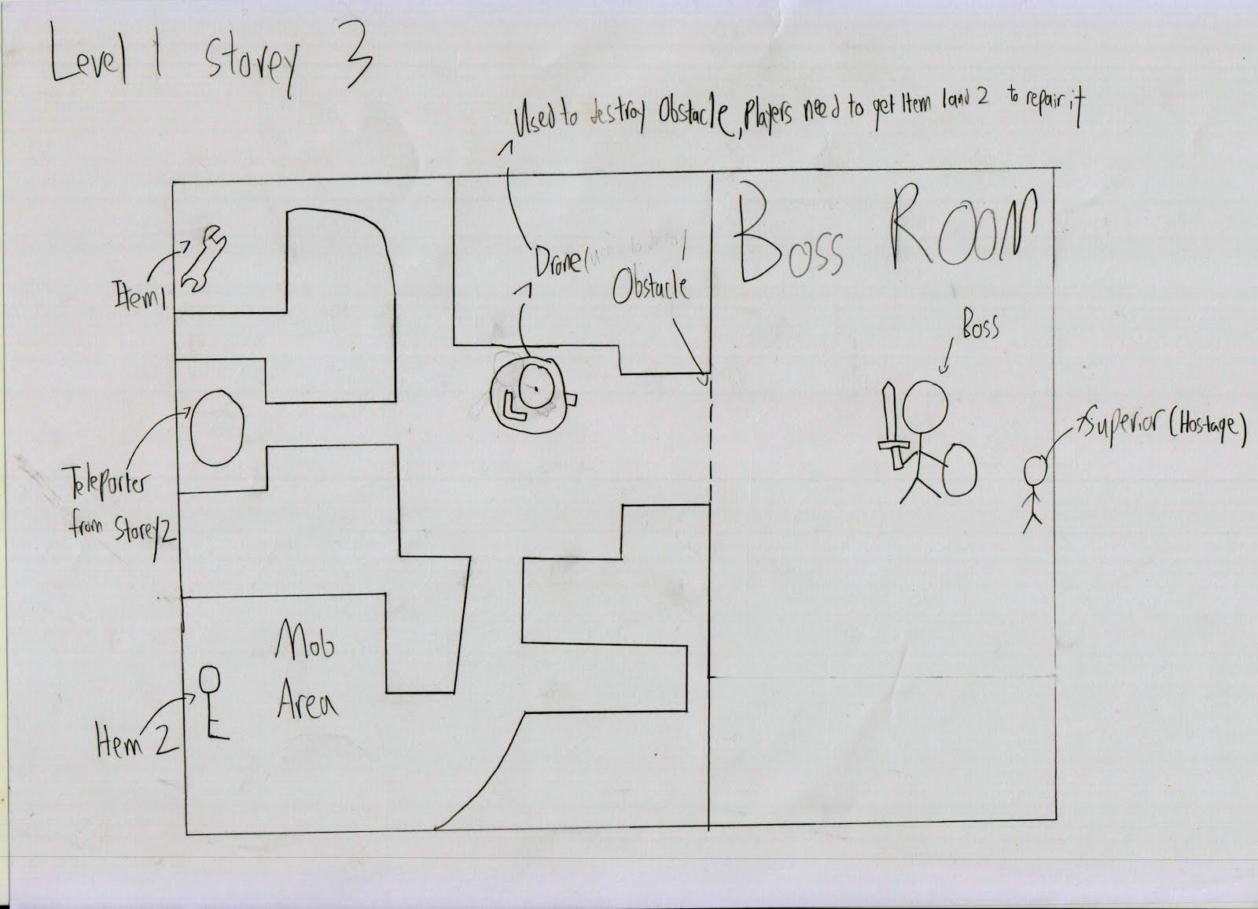The opening level of the game, used to get the player into the story.

Objects:

-Teleporters: Used to teleport to locations

-Disabled Drone: used to destroy the obstacle

-Drone part 1 and 2: used to repair drone

-Health Packs: picking them up heals the player by a certain amount

-Boss’s Sofa: environment object, can be hit with skills/kicked to attack the assailant

-Boss’s Desk: environment object, can be hit with skills/kicked to attack the assailant

-Boss’s Chair: environment object, can be hit with skills/kicked to attack the assailant

Step-by-step walkthrough

Note: No matter which faction the players select, the levels stated here are the same.

-cutscene featuring the HQ of the faction, followed by an explosion. Player’s character is seen running as though it was a training exercise, with alarm sounding in the background.-

Objective: Head to the the equipment store

-players head to the equipment store. If they try to advance without doing that, they are prevented from doing so by their avatar stating that they should head to the equipment store and it will turn back(as their characters are unarmed and unarmoured)-

Objective complete: Head to the equipment store

-cutscene showing character collecting equipment-

-explosion occurs-

NPC-Player’s superior: Oh my, you’re still alive? Hurry to the boss, he last sent an S.O.S before communications broke down.

Objective: Rescue the boss

NPC-Player’s superior: I will aid you. Let’s go.

Objective: Locate the teleporter to the next floor

-player proceeds, then gets ambushed-

NPC-Player’s superior: Get them out of the way, quickly!

-player defeats the ambush, then proceeds down the corridor before getting ambushed again-

NPC-Player’s superior: More of them?

-player defeats the ambush, the arrives at the teleporter-

NPC-Player’s superior: You’re on your own from here. I have to clear the rest of the floor. Good luck!

-player is teleported to the next floor-

Objective complete

-player arrives on second floor-

Objective: Locate the teleporter to the next floor

-player goes about the floor, locating the teleporter while fighting off mobs that appear. Various health packs around the floor keep the player alive in the event they pick a longer route and fight more mobs.-

Objective complete

-player arrives on boss floor-

-player heads to boss room, finds it blocked.-

Player’s thoughts: Perhaps there is something around here to destroy the obstacle

-player turns around, and immediately sees the drone, which triggers the next thought-

Player’s thoughts: This drone might work, but I need several parts to get it working again…

Objective: Locate the two parts for fixing the drone

-player locates the two parts, then returns to the drone, which is automatically fixed. The drone proceeds to destroy the obstacle-

-with the obstacle cleared, the boss’s room is revealed, showing the boss struggling with an assailant. The assailant spots the player and attacks the player, destroying the drone in the process.-

Objective: Defeat the assailant!

-After reducing the assailant’s health to 50%, backup arrives and fires suppressive fire at the assailant. The assailant flees and the boss is saved.-

-cutscene showing the assailant fleeing and escaping into the night-

Objective complete: Rescue the boss

Mission Clear!

**4.4 Level Two - Basement Bomb Party**

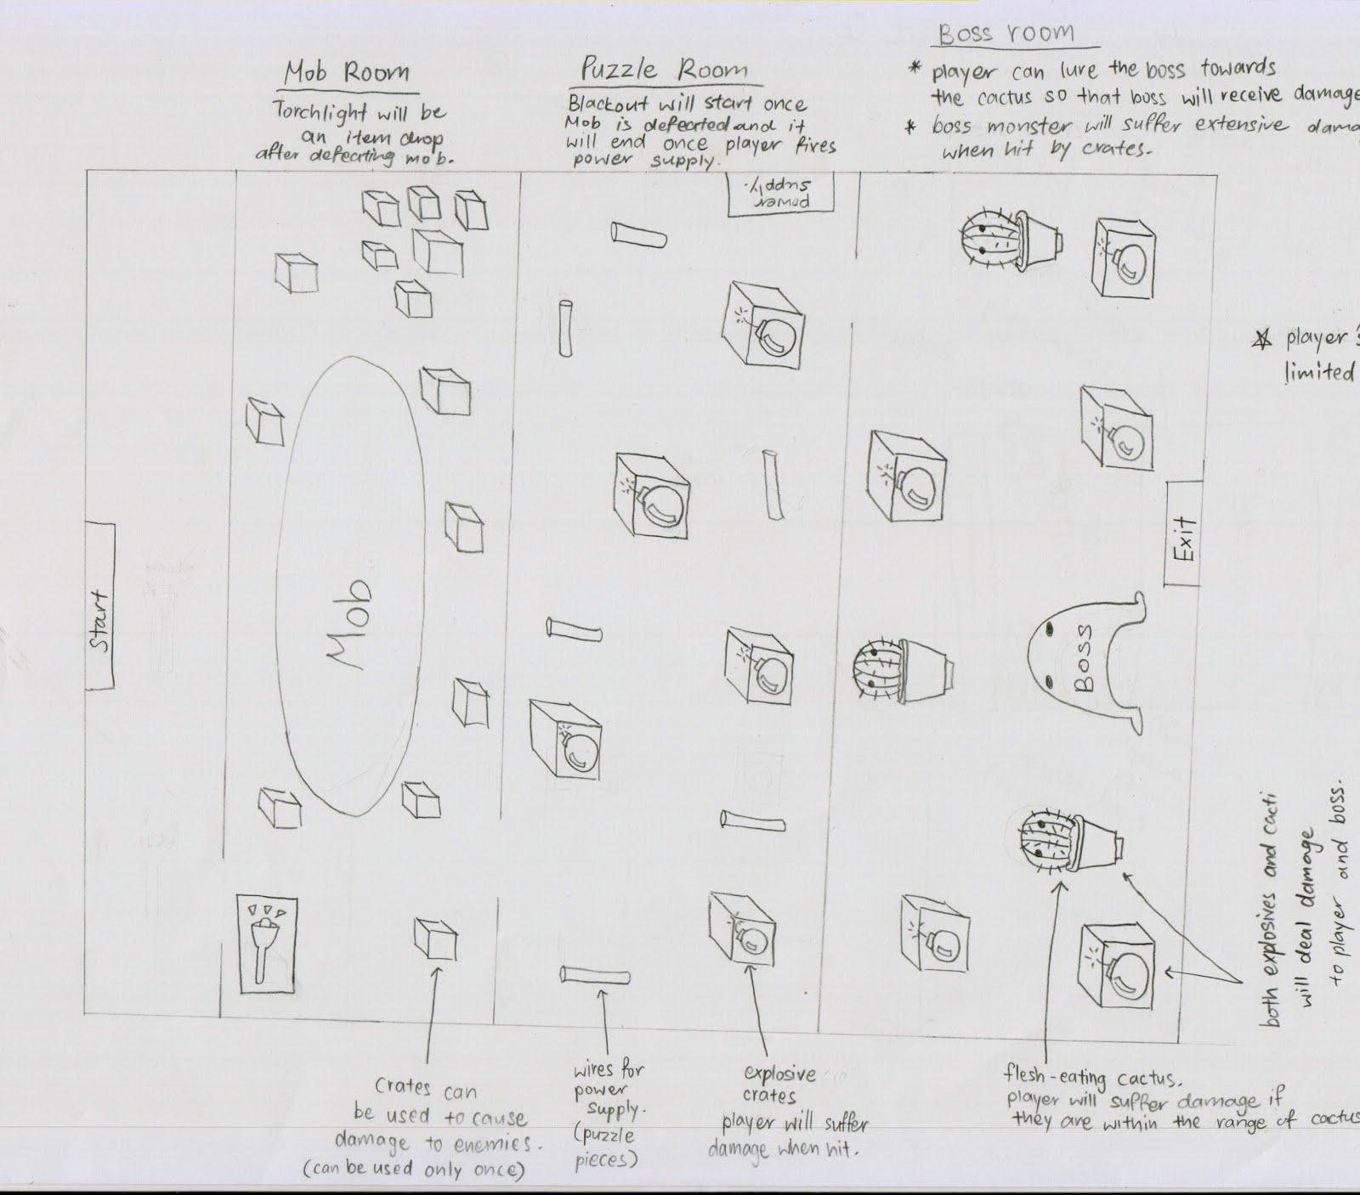

Level Two centres around allowing the player to make use of different parts of the environment to attack enemies. Player will also have to play part of the game with a limited field of vision during the blackout.

Objects:

-torchlight (to be used when the blackout occurs, gives player a limited field of vision)

-power supply (destroyed by enemy forces, player is required to fix it to get the power back on)

-power supply wires (player needs to connect the wires correctly to the power supply)

-wooden crates (can be thrown/kicked to cause damage to enemy)

-explosive crates (causes more damage than wooden crates but player will also suffer damage when they come into contact with the explosive crate)

-flesh-eating cactus (causes damage to enemy when player lures the enemy towards it. however, player will also suffer damage if they are within the range of the cactus)

*The enemies have infiltrated the HQ’s basement, it is your job to defeat the enemies without letting them get away with any valuable information.*

objective: obtain torchlight

-player enters the basement and heads towards the storage room-

-upon entering the storage room, player kicks an object lying on the floor, player picks it up realising that it is a torchlight-

player’s thoughts: Hmmm, a torchlight may come in handy later on, I’ll hold on to it.

objective complete: obtain torchlight

-player proceeds further into the room and gets ambushed by a mob hiding among the crates-

objective: defeat mob

-player can make use of the crates to attack the enemies, each crate can be used once before they are broken-

-player defeats the mob and starts to head for the door to the next room-

objective complete:defeat mob

-cutscene a small explosion is heard coming from the next room and shortly after that a blackout occurs (player’s screen turns pitch black)-

player’s thoughts: A blackout?! The enemy forces must have sabotaged the power supply with a bomb, I’ll can’t see a thing! Wait, I have that torchlight from earlier…

-player takes out torchlight, the torchlight allows player to see a limited view of what is in front of them-

-player proceeds to the next room(power generator room)-

-as player scans the room, crates of explosives and pieces of spare wires come into view-

player’s thoughts: I can make use of these spare wires to fix the power supply and get the power back on-

objective: fix the power supply and restore power to the building

-player needs to navigate a maze of explosive crates and collect the spare wires scattered around the room-

-if the player comes into contact with an explosive crate, it will cause a small explosion and cause damage to the player-

(note: explosive crates are evenly spaced out such that when one explodes, the other crates will not explode in succession)

-player collects all the spare wires and makes it to the power supply-

-fortunately, the bomb only destroyed the switch box and the wires can be easily replaced-

-player has to figure out the arrangement of the wires and fix the wires in place, power comes back on-

-cutscene: power comes back on and player’s vision goes back to normal-

objective complete: fix the power supply and restore power to the building

-player proceeds to the next room and encounters enemy boss-

objective: defeat enemy boss

-player can make use of the explosive crates (some are in clusters and will cause more damage) to deal damage to the boss, but player is also suffer damage if they are within range-

-player can also lure the boss towards the flesh-eating cactus to cause damage, players have to be careful not to be in range of the cactus otherwise they will also suffer damage-

-player defeats boss and restores order in the basement-

Objective complete: defeat enemy boss

Mission Complete!

**4.5 Level Three - Alerting the Others**

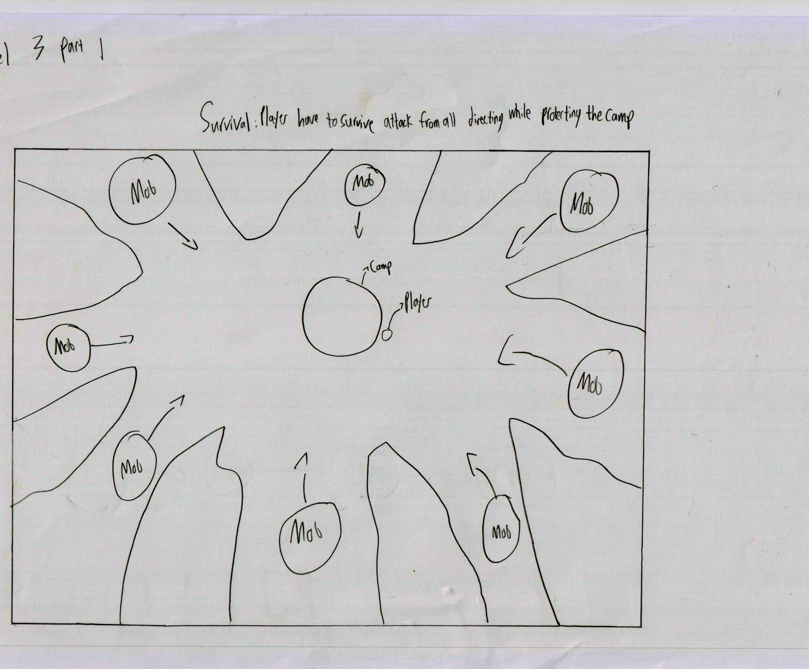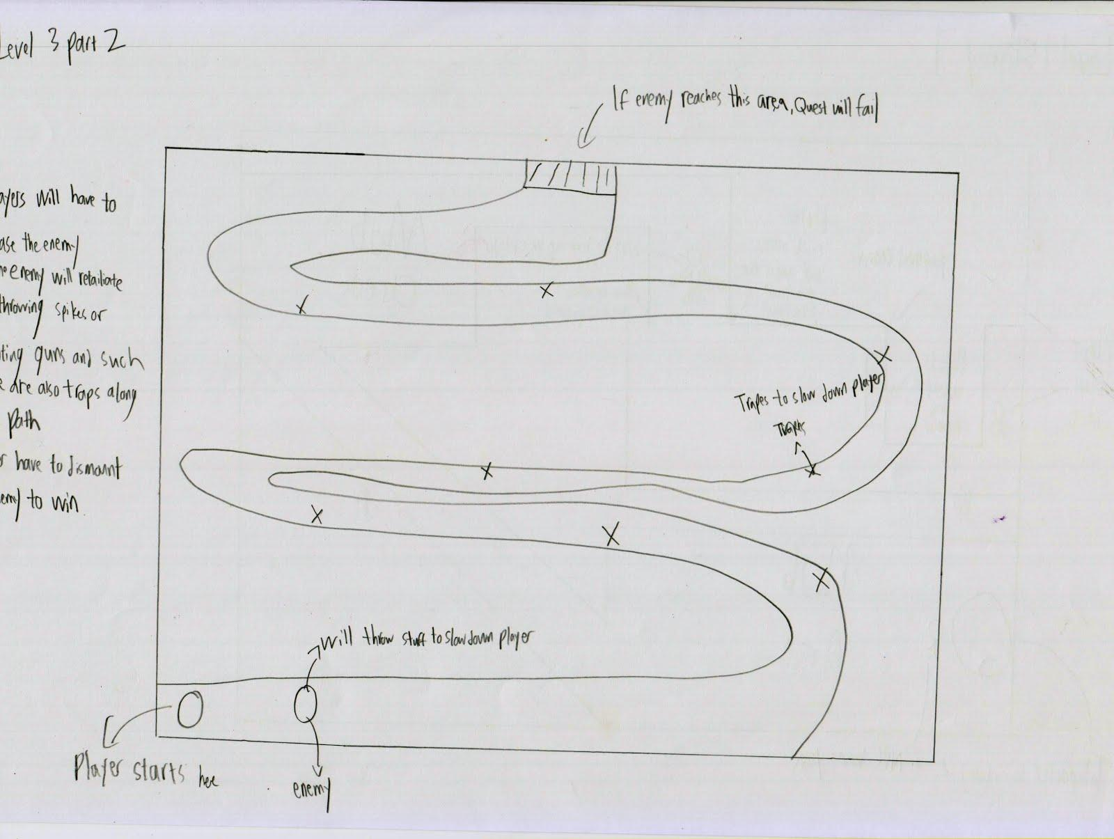

Level Three allows the player to feel more dynamic combat by having waves of enemies assault the player. It also introduces positioning to allow the player to learn to defend, rather than blindly charging. Finally, it introduces the mount system to the player.

Objects:

-Barrels: Environment objects which can be kicked as projectiles

-Command Center: The building that the player has to defend

*The boss has instructed you to travel to a base camp as communications have yet to be restored following the previous attack. Your objective is to inform the Captain there regarding recent attacks, and in accordance with your boss’s wishes, to step up security as the location is important for future development of Neo Earth. The boss has also kindly allowed you to use the teleporter at HQ as a shortcut.*

-cutscene featuring the player receiving a briefing from the player’s superior regarding the mission-

Objective: Head to the base camp

-players use the HQ teleporter and teleport to base camp-

Objective Complete: Head to base camp

-upon teleporting, players see the camp under attack-

Player’s thoughts: What in the… My original mission aside, defending the camp is what matters now!

Objective: Defend the camp until reinforcements arrive

-players use their skills, attacks and understanding of the environment to defend the base from the invaders.-

Objective Complete: Defend the camp until reinforcements arrive

-cutscene showing reinforcements arriving, although more enemies have arrived. The player is requested to assist the Captain-

Base Captain: Aren’t you the messenger from Justicar City? As you can see things aren’t quite ready for report-delivering. Mind giving me a hand here?

Objective: Assist the Captain in defending the command center

-players defend the command center and prevent it from taking too much damage from attacks-

Objective Complete: Assist the Captain in defending the command center

-cutscene showing player and the Captain defeating the waves of enemies. It then shifts to the lone survivor fleeing from the camp using a mount-

Base Captain: Take my mount and chase him. If he gets away we’re dead. Go!

Objective: Catch and eliminate the survivor

-players catch the survivor in a time-limited mounted chase, de-mount the survivor using the interaction button when they are close enough, and kill the said survivor.-

Objective Complete: Catch and eliminate the survivor

Mission Complete!

-cutscene showing player delivering the report, as was the player’s original mission.-

Player’s thoughts after cutscene: A mount huh...I might consider getting one.

**5 .1 Player Controls and class skills**

Players are able to modify the controls to their liking. However, the controls have been preset by the game. They are:

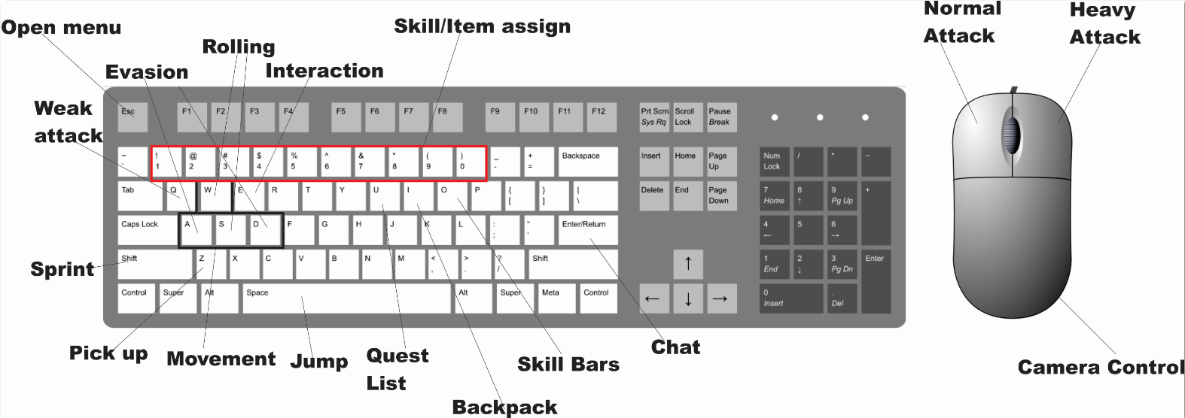

|  |  |
| --- | --- |
| **Keyboard Functions** | **Actions** |
| W | Forward |
| A | Left |
| S | Right |
| D | Backward |
| AA or DD**(Double Tap)** | Evasion |
| WW or SS**(Double Tap)** | Rolling |
| L.Shift with W | Sprint |
| Spacebar | Jump |
| Z | Pick up items |
| E | Interaction with environment or mount |
| Q | Weak attack**(Kick)** |
| Mouse | Camera control |
| Left Button Mouse | Normal Attack |
| Right Button Mouse | Heavy Attack**(non-shield user)**  Block**(Shield User)** |
| Button 1 to 9 | Skill/item assign |
| U | Quest List |
| Enter | Chat |
| Open Menu | Esc |
| I | Backpack |
| O | Skill Bars |

**Main Menu:**

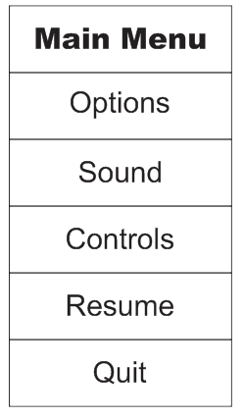

**Class Selection:**

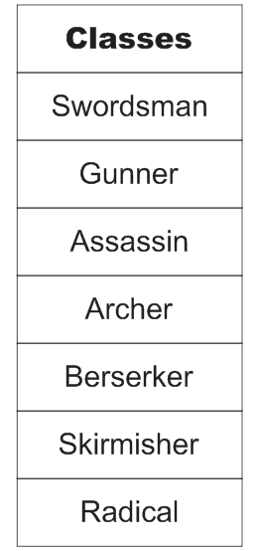

**Shop UI:**

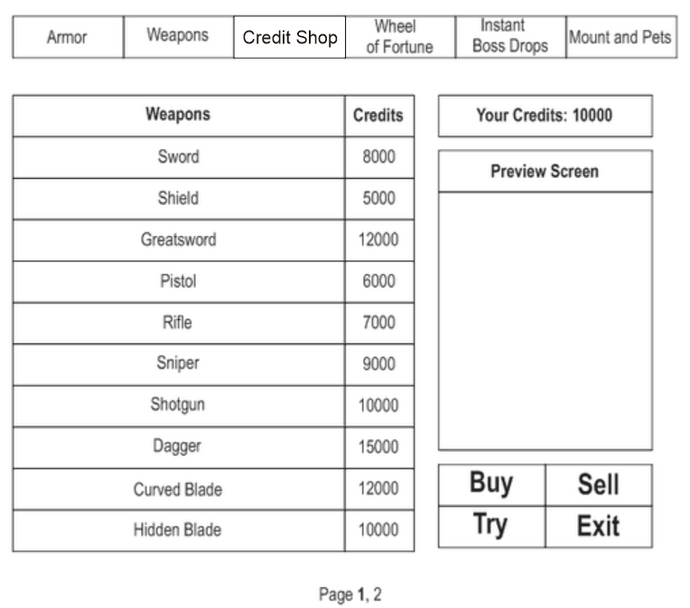

**Player HUD:**

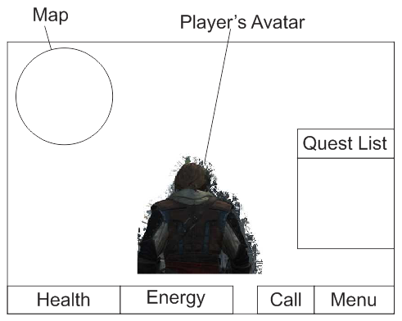

**5.2 Currencies in-game**

There are two currencies used in Neo Revolution Online.

1) IGC(In-game cash): This is the basic form of money in game, used to purchase equipment and consumables. They can be earned from killing mobs, selling items, completing quests, duels in the arena and gambling house.

2) Neo-Credits(Credits for short): The virtual currency that is earned by paying real money into the game, and converting it. Used for Microtransactions.

**5.3 Microtransactions**

There are several forms of microtransactions in-game, some affecting the stats of the character, while others are purely aesthetic. All Microtransactions are carried using Credits, which can be gotten by players spending real money to convert the amount spent to Credits.

**1) Player Aesthetics**

a)Player Aesthetics fall under three categories: Weapon Skin, Armour Skin and Skin Uploader Coupons.

b)Weapon skins are skins that cover the player’s current weapon with the skin bought from the shop. They do not provide any boosts in the player’s stats, and are purely aesthetic. These are separated by the weapons of each specialisation.

c)Armour skins are skins that work similarly to a weapon skin, except that they cover armour instead. These are separated by Helms, Body Armour(further split into Upper Torso, Lower Torso, Overall), Gloves, Boots, Capes.

Note: If an overall is worn, Armour skins for upper torso and lower torso can be worn over it. If the player only has the armour skin for the upper torso when an overall armour is worn underneath, the avatar is shown to be unarmoured for the lower torso and vice-versa.

d)Skin Uploader coupons are coupons used to upload a custom skin that players have created themselves. Neo Revolution Online allows players to export the skin file of the purchased skin(be it weapon or armour), and design their own(the form of the skin is retained, players only are able to change the design on the skin, not the skin itself) as player customisability is a core aspect of the game. However, to use the skin that they have designed, they are required to purchase a Skin Uploader coupon before they are able to upload their custom skin.

**2) Instant Boss Drops**

Rare boss drops are often valued by every player in the game. However, not everyone is able to get it easily. Using Credits to purchase boss drops are a way to allow unlucky players to gain a boss drop quickly(although they must still fit the stat requirements of the equipment). However, gaining boss drops this way will not have the optimal stats of the equipment, as a form of game balance for players who have worked hard to gain boss drops through repeatedly defeating a boss.

**3) Wheel of Fortune**

Another method for gaining rare boss drops is through the lottery. Players can use Credits to spin the Wheel of Fortune

, which has the potential to drop rare boss equipments that are of equal stats to the ones dropped by the boss. There are 4 different lottery wheels. The 1st is for weapons of all classes. The 2nd is for weapons of a specific highlighted class of the player. The 3rd is for armour of all classes and finally the 4th is for armours of a specific highlighted class of the player. Game balances are offset by several factors.

Firstly, players may not get the weapon/armour that they are attempting to get, due to the numerous classes and different level equipments. While the chances of getting an equipment to a relevant class is increased by using a specific class lottery wheel, it is offset by having a higher price, which is covered in the next point.

Secondly, class-specific lottery wheels use significantly more Credits than the other lottery wheels. It forces paying players to consider the price difference in the different lotteries. The mindset of the player at that point of time may also influence the decision. Perhaps players might also purchase both types of lottery wheels?

Thirdly, the lottery is not limited to rare boss drops. The lottery itself also contain above average(but not necessarily good) equipments of all levels, and even average equipments of high levels. It reduces the chance of getting the boss drops, while ensuring that players are not turned off by the poor chances by including relevant equipment for them to be able to dish out decent damage in the event that they do not draw a boss drop.

**4) Mounts and pets**

Mounts are steeds that can only be gotten through Credits. They allow the player to travel quicker than on foot from one place to another in Travel Mode. It can also be used in cities. Mounts are automatically disabled if the player encounters mobs in Travel Mode, and can be remounted once the battle is over. It is also a sign of prestige, which appeals to players. After all, who doesn’t look good when they are sitting upon a large steed and towers over everyone else?

Pets are small companions that can also only be gotten through Credits. Unlike mounts however, they aid the player in combat by providing small passive boosts to the player’s stats. They feature a maximum of four boosts, but only one can be used at the start, the rest requiring credits to unlock. The players are however, able to select which boost they desire. Pets have many types, ranging from everyday house pets to miniaturised mobs and bosses.

**Character Rendering**

As Neo Revolution online emphasises customisability, the characters can be designed according to the player’s preference. Hairstyles can be selected from a wide range of hairstyles, and then modified to the player’s preference such as hair length and colour. Facial styles can also be selected by each individual part(eyes, nose, mouth) to form a unique combination by the player. Even the body itself can be selected by the player and modified accordingly(broader shoulders, muscle size, etc).

As a general note, male characters are noted to be somewhat more masculine and wear more clothing/ have thicker armour.

Female characters have shapelier bodies, and their armour is thinner in certain areas, even exposing parts of their body, especially prominent in battle armour.

**5.4 Armour in depth**

Character armour is categorised into several sectors. They are:

- Helm(Character’s Head)

-Upper Torso(Upper body of the Character)

-Lower Torso(Lower body of the Character)

-Overall(Entire body of the Character)

-Gloves(Hands of the character, may cover elbows as well)

-Boots(Feet of the Character)

-Cape(Garment worn over the shoulders of the character)

Further Categorising the armours are:

-Heavy Armour

-Light Armour

-Battle Armour

a)**Heavy armours** are classified as armour that feature high defensive capabilities and also increase attack by a certain amount. However, they often slow down the character’s movement speed.

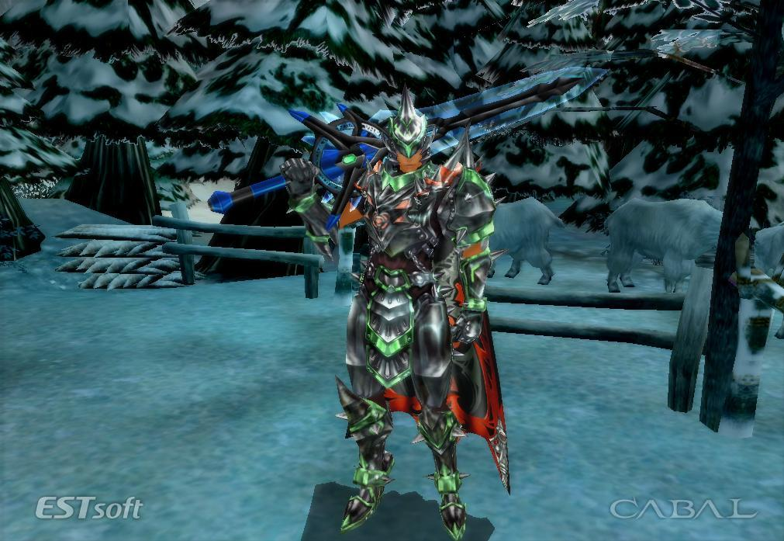

The appearance of heavy armour will not vary very far from classic medieval armour. However, in line with the futuristic theme, the trimmings of it will shine on its own and the general overview of it appears to be as though it is polished. All areas, even the hands, are clad in armour.

b)**Light armours** are classified as armour that are the opposite of heavy armour. They increase character’s movement speed and evasion, but have low defensive capabilities. They do not increase character attack, or have very little increase in rare cases(such as boss drops) that the boost provided is negligible.

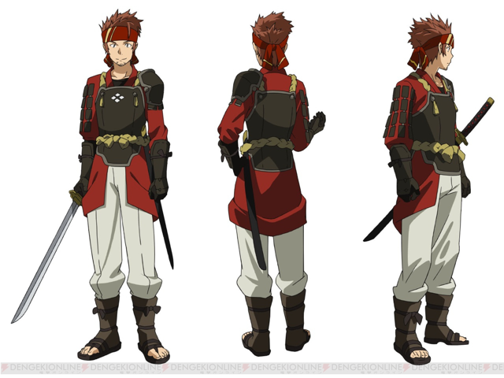

Light armour only protects key areas such as the chest, shoulders and hips. The rest of the body is lightly armoured or even unarmoured for better movement.

c)**Battle armours** are classified as armour that are even lighter than light armour, often having little to no defensive capabilities. However, they increase the attack of the character, and have above average movement speed OR evasion(though not as high as light armour).

Note: If the battle armour in question provides a boost in movement speed, the evasion boost it provides is still present, but is average at best. It also applies vice-versa.

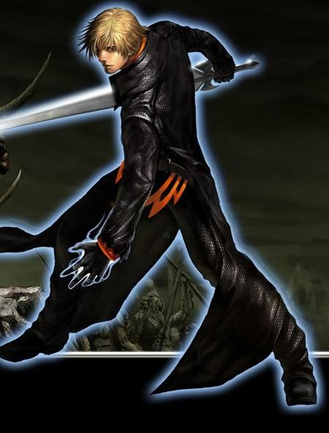

Battle armour lacks any form of armour, and uses padded clothing only for freedom of movement and lightweight for speed.

d)Players are able to mix and match their armour to form the ideal set of their desires, and are not required to stick to one particular armour set. Having the full set of armour of the same level also further provides a small boost in their stats.

**5.5 Weapons in depth**

**a)Sword**

As our setting is in the future the sword must have be able to “absorb” the user’s energy,sort of like this.

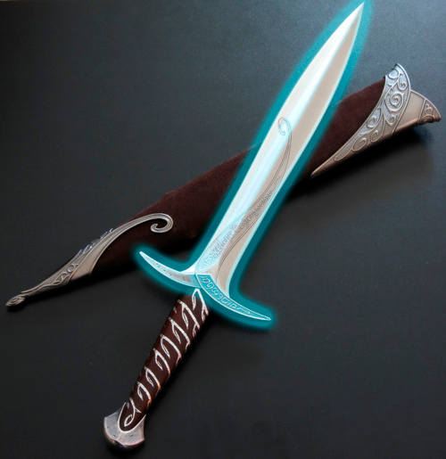

or

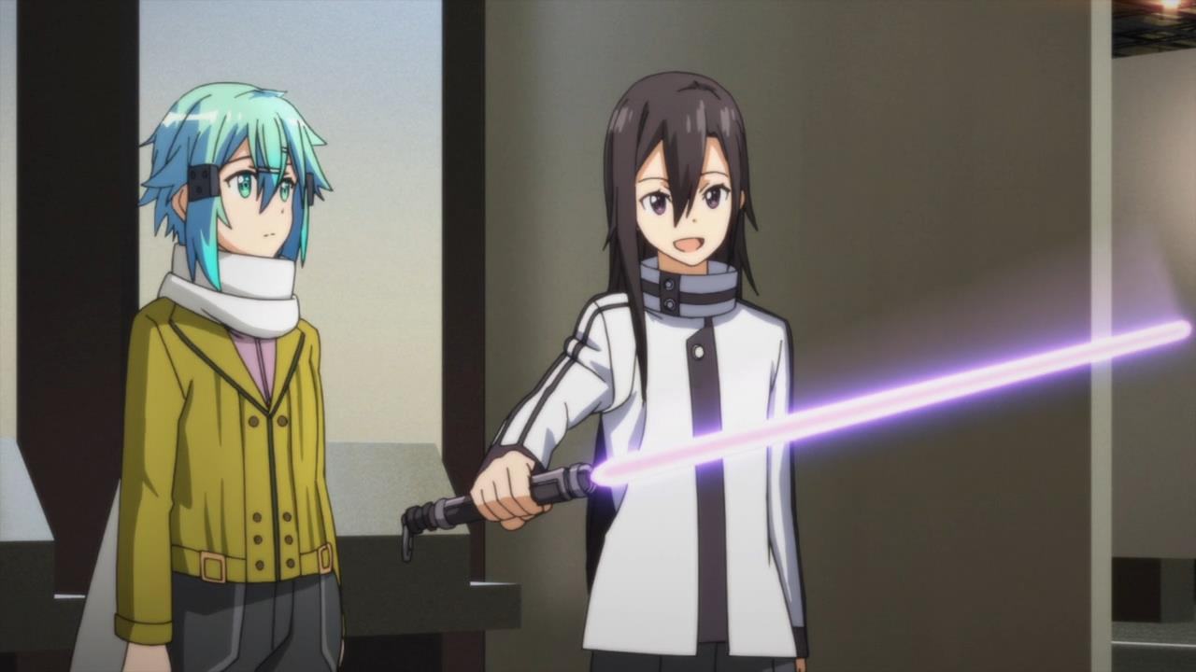

**b)Shield**

For our shield as it is the future players should be able to have a hologram shield or physical shield depending on their choice and their class

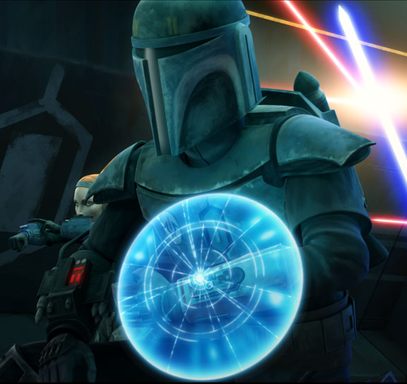

Hologram Shield for class that can equip shield

or



Physical Shield for the Avenger class only

or

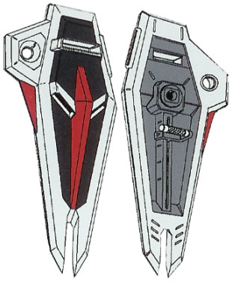

Physical shield for all shield usable class

**c)Greatsword**

As it is the future we want a Greatsword that will glow in the dark from energy absorbed from the users.So that it will look futuristic or we can have a Greatsword that looks normal except that it is reinforced witrh future materials.

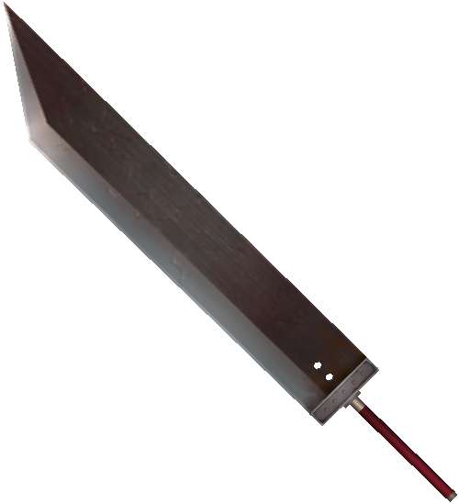

or

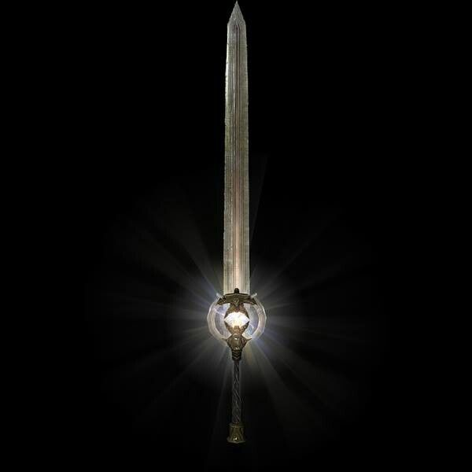

**d)Pistol**

For the pistol we have 2 types one that fire energy rounds and another one that fire live rounds

The energy guns are able to fire faster but have lesser damage which are ideal for mob battles but as for the live round guns,it fires slower than the energy round but have a higher damage output making it ideal for PvP

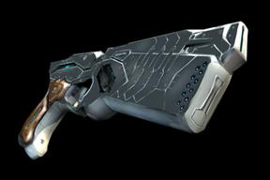

This fires energy rounds

and

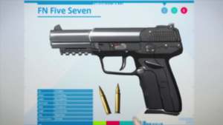

This fires live rounds

**e)Rifle**

Similar to the pistol we have 2 types of rifle one that fire energy rounds and another one that fire live rounds.The energy guns are able to fire faster but have lesser damage which are ideal for mob battles but as for the live round guns,it fires slower than the energy round but have a higher damage output making it ideal for PvP

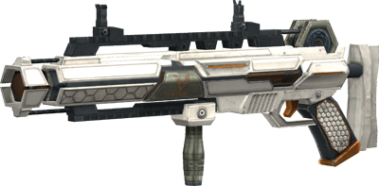

This fires laser rounds

and

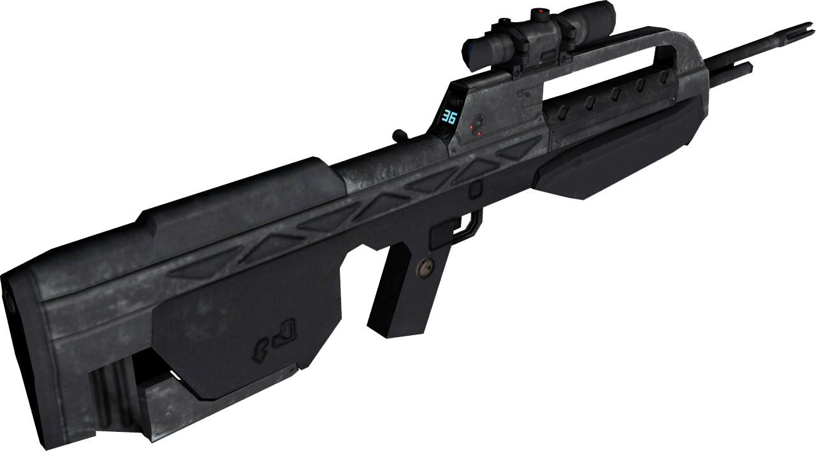

This fires live rounds

**f)Sniper**

Like all guns in the future we would like two types one that fires energy rounds and one that fire live rounds.The energy guns are able to fire faster but have lesser damage which are ideal for mob battles but as for the live round guns,it fires slower than the energy round but have a higher damage output making it ideal for PvP

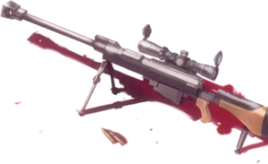

This fires live rounds

and

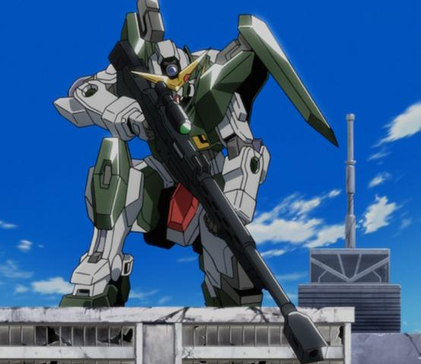

This fires laser rounds

**g)Shotgun**

Like all guns in the future we would like two types one that fires energy rounds and one that fire live rounds.The energy guns are able to fire faster but have lesser damage which are ideal for mob battles but as for the live round guns,it fires slower than the energy round but have a higher damage output making it ideal for PvP

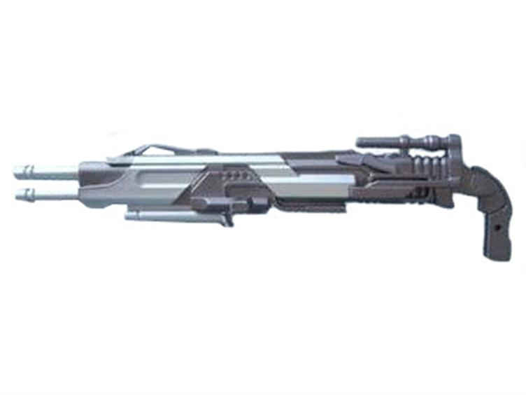

This fires live rounds

and

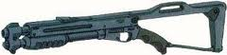

This fires energy round

**h)Dagger**

As it is the future we would have to have a weapon that utilize the energy from the users,but they have to look ‘normal’ as a dagger that glows in the dark is not stealthy

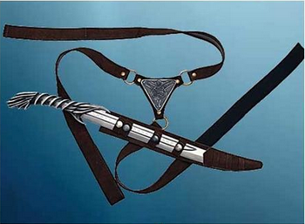

**i)Curved Blade**

Similar with the dagger if a weapon glows in the dark for stealthy character they would be found out easily so we went with a steel curved blade.

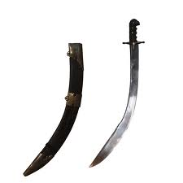

**j)Hidden Blade**

As a stealth character,it is important to have a low profile weapon so that you are not spotted easily.For the hidden blade as it is small and the blade could be discreetly extended or retracted making it a stealthy weapon

making

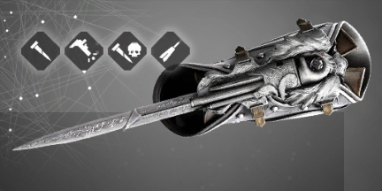

Players could start out with only the blade

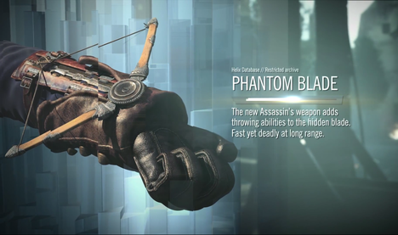

As they progress through the game they may add gun or a mini crossbow to their hidden blade

**k)Lance**

The lance is aimed to aimed to “absorb” the users energy and then gather it at its tip as such we feel that it should also glow due to electricity passing through it.

Such as:

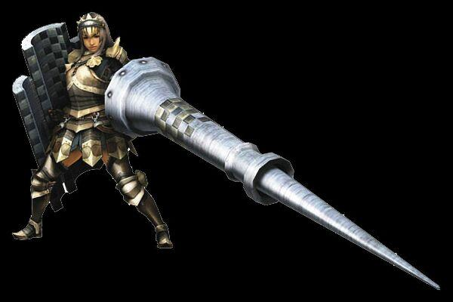

**or**

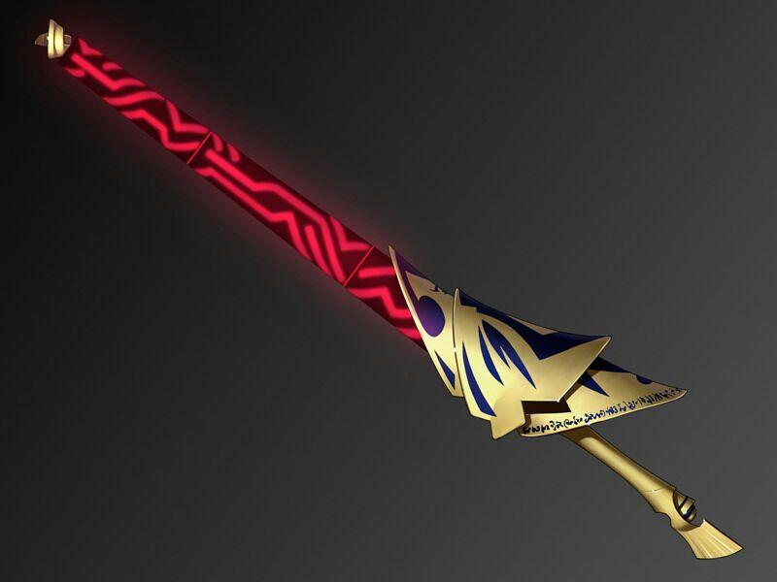

**l)Axe**

As our game is set in the future,similar to the sword the axe should also reflect that it is the future.

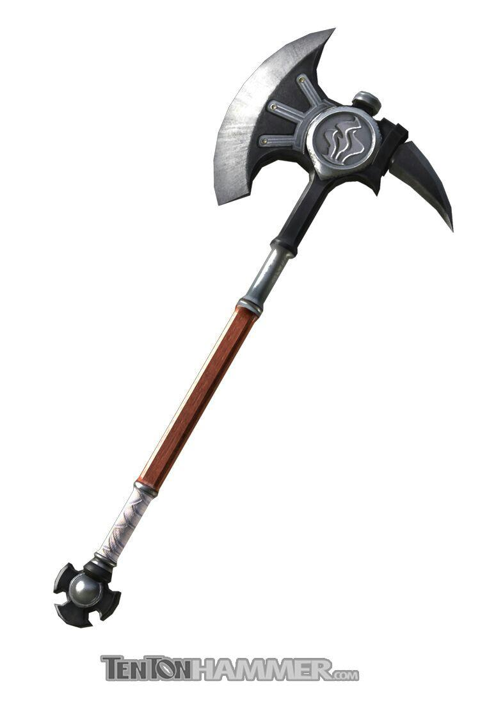

or

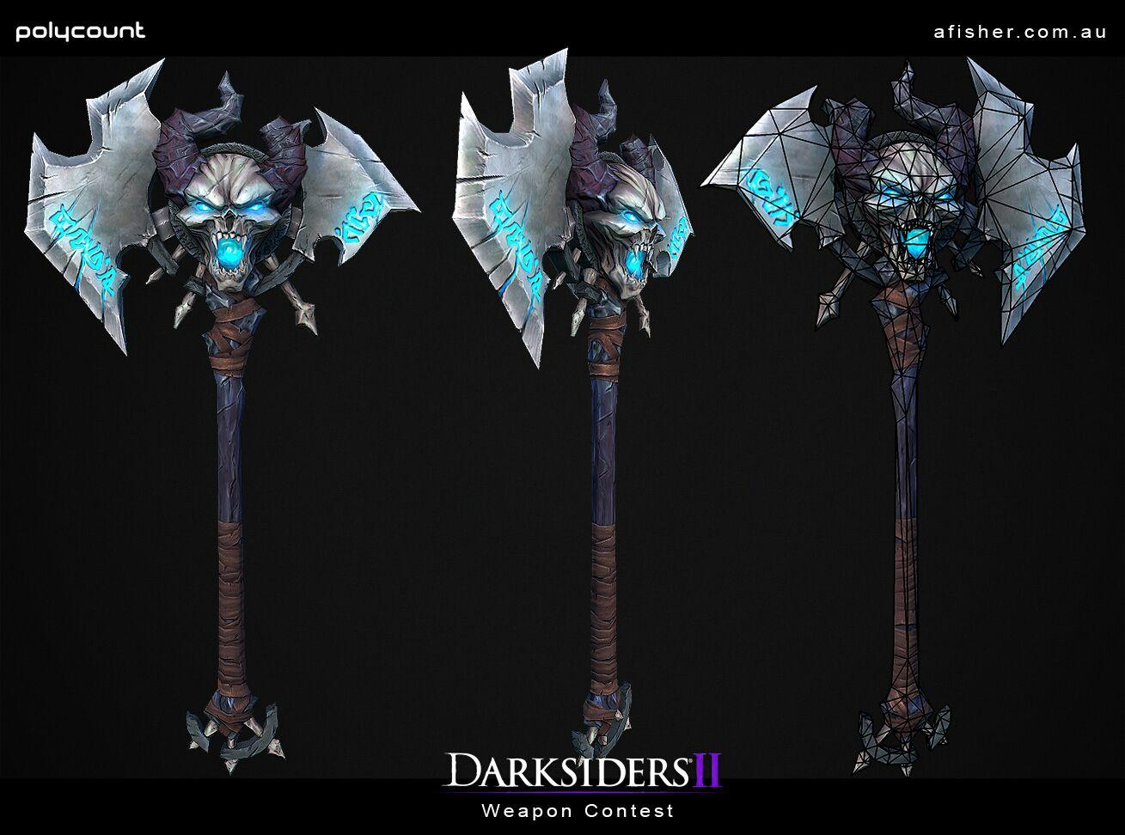

**m)Spear**

As the game is set in the distant future the weapon itself should scream the future with energy edges and such

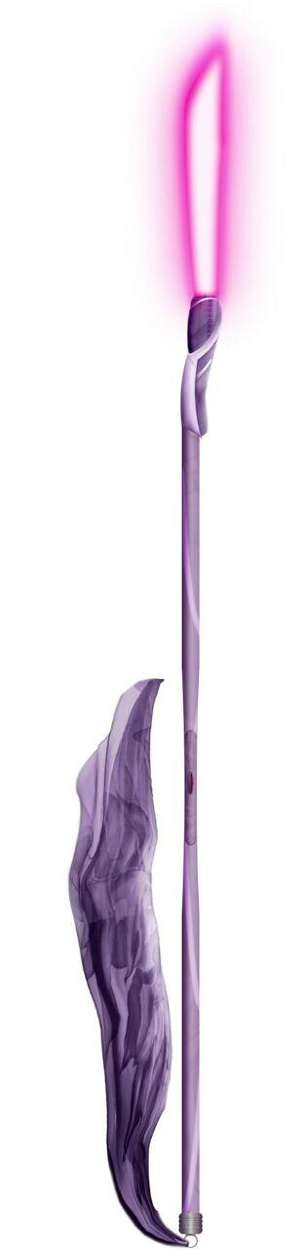

**n)Polearms**

For the polearm,it should be made up of futuristic metal so as to enhance its durability but retain its beauty at the same time

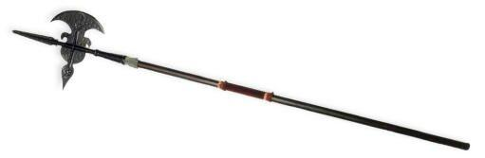

or

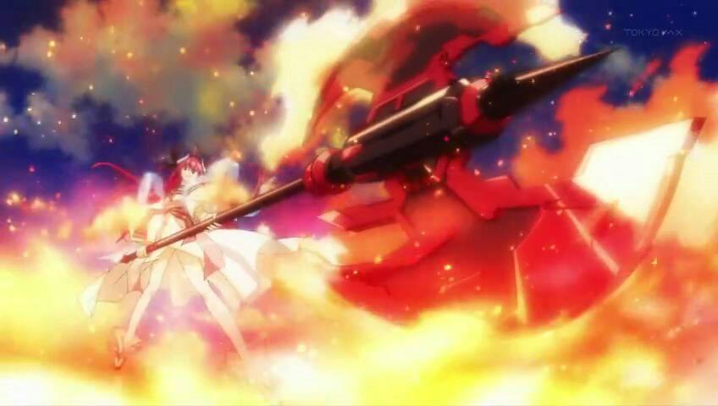

**o)Glaives**

Similar to the Polearm,as it is in the future it should be made up of futuristic metal so as to enhance its durability but retain its beauty at the same time

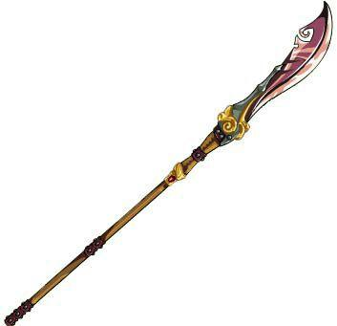

**p)Staff**

The staff should be upgraded with future technology so as to reflect that the game is in the future.

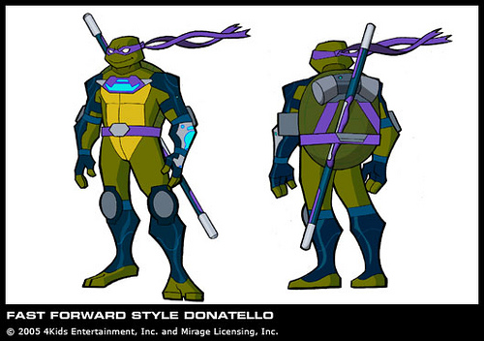

**q)Jetpack**

For the Shield Gunner class,the jetpack is to enable them to move faster to dodge enemy attack and such however as they advance through the game they are able to upgrade it to help them attack.

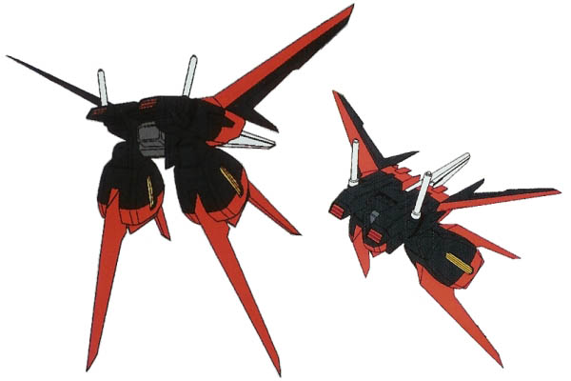

This is what starting players can use

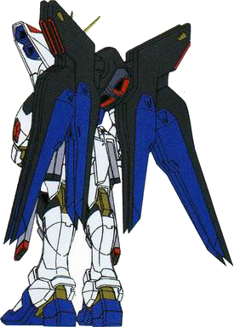

Player can upgrade to this to boost their attack

or

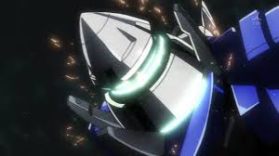

This to boost their speed

**r)Bow**

As it is the future,the bow should be upgraded so as to ensure or reflect that their bows are more suited for combat use

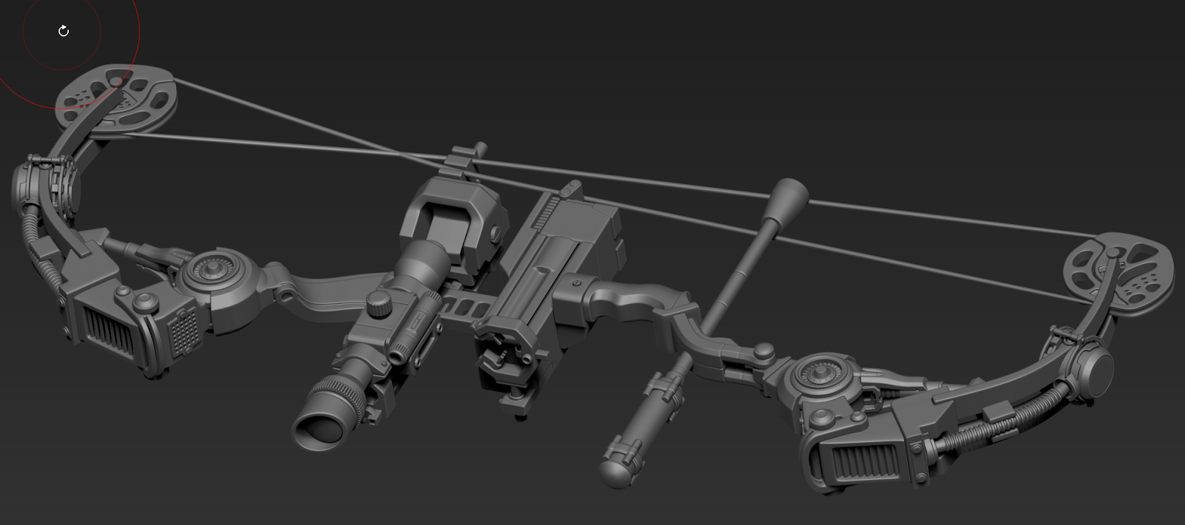

**s)Crossbow**

The crossbow have been upgraded so as to show that the game is in the future.

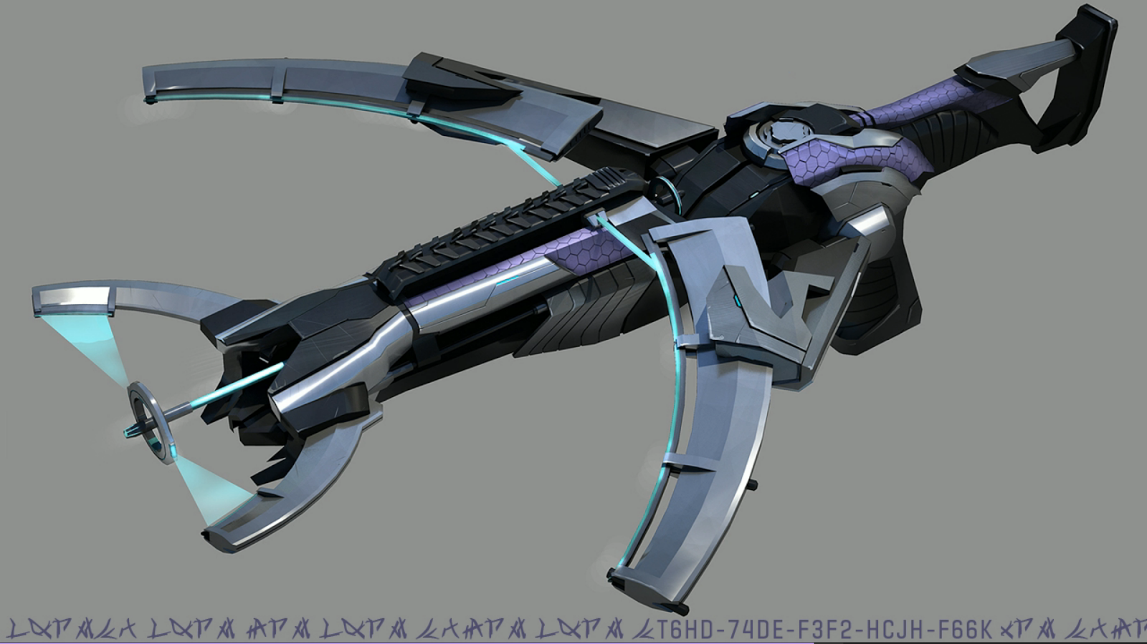

**t)Katana**

For the Katana,it should be made up of futuristic metal so as to enhance its durability but retain its beauty at the same time as it is the beauty of the Katana that makes it popular

